

Secure Fingerprint Authentication Using Machine Learning and Deep Learning: A Comparative Security Evaluation

Mahesh Marri
B01799979

Thesis for the partial fulfilment
of the requirements for the Masters Degree
in MSc Cyber Security

University of the West of Scotland
School of Computing, Engineering and Physical Sciences

23/04/2026



DECLARATION OF ORIGINALITY

I declare that this is an original study based on my own
work and that I have not submitted it for any other
course or degree.

Signature : Mahesh Marri



Library Form to Accompany MSc Project

  - To be completed in full

Surname: Marri

First Name: Mahesh Initials: M.M

Banner No: B01799979

Course Code: COMP11024

Course Title: Masters Project

Project Supervisor: Dhriti Singh

Project Title: Secure Fingerprint Authentication Using Machine Learning and Deep Learning: A Comparative Security Evaluation

Session:23/04/2026 Date of Submission:

Signature:Mahesh

Please ensure that a copy of this form is included with your project before submission.

Abstract:

Fingerprint authentication is one of the most widely deployed biometric security mechanisms, yet its resilience against presentation attacks and cross-sensor variability remains an open research challenge. In this work, four machine learning and deep learning models are applied and comparatively analyzed such as Convolutional Neural Network (CNN), a Hybrid CNN with Batch Normalization and Dropout, a Support Vector Machine (SVM) with Histogram of Oriented Gradients (HOG ) extraction, and a Random Forest ensemble as the binary genuine-versus-spoofed fingerprints classifiers. Each model is trained on the Sokoto Coventry Fingerprint Dataset (SOCOFing) using the same preprocessing and evaluation parameters, with the False Acceptance Rate (FAR) as the main security measure. On the primary dataset, CNN attains excellent security and usability with 97.36% recognition, a FAR of 8.11 and a FRR of 0.82 whereas the SVM has the best security performance with minimum FAR of 5.60. External validation with testing dataset offers useful information about the variations in model performance in relation to sensors and acquisition conditions and identifies promising directions such as multi-domain training, cross-sensor evaluation to further enhance deployment robustness. Overall, the findings demonstrate that machine learning-based fingerprint authentication is not only technically feasible but highly adaptable, offering a strong foundation for next-generation biometric security systems.

Keywords: Fingerprint Authentication, Biometric Security, Convolutional Neural Network, Support Vector Machine, False Acceptance Rate, Presentation Attack Detection.

Table of Contents
Abstract: 4
Chapter 1: Introduction 9
1.1 Background: 9
1.2 Problem Statement 10
1.3 Project Overview and Datasets 11
1.4 Aim 11
1.5 Objectives 11
1.6 Research Questions 12
1.7 Report Structure 12
Chapter 2: Literature review 14
2.1 Traditional Fingerprint Authentication Methods 14
2.2 Machine Learning Classifiers in Fingerprint Authentication 15
2.3 Deep Learning Approaches in Fingerprint Authentication 17
2.4 Presentation Attack Detection 18
2.5 Multimodal and Distributed Authentication 20
2.6 Adversarial Robustness and Model Generalisation 22
2.7 Summary and Research Gaps 23
Chapter 3: Research Methodology 25
3.1 Research Design 25
3.2 Datasets 26
3.3 Preprocessing Pipeline 26
3.4 Feature Extraction 27
3.5 Model Specifications 28
3.6 Evaluation Framework 28
3.7 Ethical Considerations 29
Chapter 4: Implementation 30
4.1 Overview 30
4.2 Dataset Acquisition and Organisation 30
4.3 Deep Learning Pipeline: CNN and Hybrid CNN 31
4.4 Classical ML Pipeline: SVM and Random Forest 34
4.5 Security Metric Computation 35
4.6 External Cross-Dataset Validation 36
4.7 Implementation Environment and Reproducibility 37
Chapter 5: Results and Discussion 38
5.1 Dataset Overview 38
5.2 Models results under Training Dataset 40
5.3 Models Comparative Analysis 43
5.4 External Dataset Generalization Results 44
5.5 Comprehensive Cross-Model Discussion 46
Chapter 6: Conclusion 48
6.1 Summary of the Study 48
6.2 Key Findings: 48
6.3 Answering the Research Questions 49
6.4 Contributions 50
6.4 Limitations and future work 50
6.5 Critical self-reflection 51
References: 52
Appendix: 55

Table of figures:
Figure 1: System design (self-made). 26
Figure 2: Data preprocessing pipeline (self-made). 32
Figure 3:CNN model implementation and training (self-made). 33
Figure 4: Hybrid CNN model implementation and training (self-made). 34
Figure 5: HOG feature extraction and ML models training (self-made). 35
Figure 6: Evaluation metrics implementation (self-made). 36
Figure 7: External dataset testing g (self-made). 37
Figure 8: Dataset distribution (self-made). 39
Figure 9: Sample images of the dataset (self-made). 40
Figure 10: CNN model performance (self-made). 41
Figure 11: Hybrid CNN model performance (self-made). 42

List of tables:

Table 1: Models Comparative analysis table (self-made). 44
Table 2: External dataset models performances (self-made). 45

Chapter 1: Introduction

Background:
Biometric authentication is now an inseparable part of the current structure of cybersecurity, which is gradually substituting or enhancing traditional knowledge-based credentialing systems in a vast number of operational settings. Largely, organisations in industries including enterprise IT, financial services, healthcare, government and border control are moving towards biometric frameworks as part of a wider shift towards password less identity verification (Ghilom and Latifi, 2024). Such a shift cannot be attributed solely to any technological preference but indicates the quantifiable ineffectiveness of passwords as a form of security control at scale. Passwords can be phished, brute-force enumerated, credential-stuffed, and social-engineered. They are constantly forgotten, re-used through the systems of many systems and shared in a manner that is always detrimental to the security policy despite the stringency of the enforced security policy. Biometric characteristics, conversely, are intrinsically tied to the person, they cannot be guessed, passed on, or forgotten, and thus, they are structurally better to base security-sensitive authentication on.
Of the many biometric modalities that can be used, such as iris recognition, facial recognition, voice recognition, gait recognition, and vascular pattern recognition, fingerprint recognition has held a leading role in both commercial and public-sector implementations over the past few decades. This eminence can be explained by a set of well-understood properties, namely the uniqueness of ridge patterns in individuals on a population scale, the stability of fingerprint morphology over the entire lifespan, the relative maturity and cost-effectiveness of capacitive and optical sensor technology, and an extensive history of empirical validation in forensic science and law enforcement practice (Rahman et al., 2022). Hundreds of millions of consumer products such as smartphones, laptops, and physical access control terminals, and specialised government and enterprise systems to execute sensitive identity verification tasks, now use fingerprint sensors. The extent of deployment implies that any systematic security defect in the fingerprint authentication systems exposes it at a proportionate extent.
In spite of this maturity and ubiquity, fingerprint authentication systems are still subjected to severe and well-documented security constraints. Traditional systems are designed based on manually developed feature extraction methods, and the most common paradigm deployed is minutiae-based matching. These techniques determine the structural features of the fingerprint, namely ridge endings and bifurcations, encode them in a mathematical template and make a comparison with stored enrolment information to generate an authentication response. Although this method is sufficiently effective in controlled acquisition situations with homogeneous sensor hardware and cooperating users, it becomes very weak when the conditions of real-world deployment are considered. Noise in the environment, variability in user pressure, distortion caused by moisture or dryness, partial fingerprint capture, cross-sensor variability across hardware platforms, and intentional adversarial manipulation of input images all contribute to the reduction in reliability of minutiae-based matching (Maiti et al., 2024). These debasements are not simply scholarly issues in working systems, low classification reliability would convert directly into high error rates with real security implications.

The Role of Machine Learning and Deep Learning:
In the recent past, machine learning and deep learning have made significant progress to increase the tools that can be used in fingerprint authentication and spoof detection. Convolutional Neural Networks (CNNs) have shown the ability to directly learn discriminative spatial representations of fingerprint ridge texture, pore distribution, and liveness cues directly using raw image data, without the need to manually design feature descriptors, which is a requirement of classical methods (Garg et al., 2024). CNNs, when trained on adequate labelled data and with suitable preprocessing and augmentation, are able to spot spoofing artefacts invisible to minutiae-based matchers and can also generalize to varying acquisition settings. This ability is extended by hybrid CNN models that add Batch Normalisation and Dropout regularisation layers to be more stable in training and to reduce overfitting, especially in cases where the amount of training data is small compared to the model complexity (Hussain et al., 2025).
Classical machine learning methods are still pertinent and points of comparison. A computationally efficient Support Vector Machine (SVM) classifier using handcrafted feature descriptors like the Histogram of Oriented Gradients (HOG) can serve as a well-understood, highly theoretically motivated, and well-grounded high-dimensional classification baseline (Youseuf et al., 2025). The HOG descriptors describe the local distribution of gradient orientations in image cells and blocks representing the edge and texture information which is informative in the process of differentiating between real and distorted fingerprint images. Random Forest classifiers, which combine predictions on a series of decision trees trained on random subsets of features, are resistant to noise and competitive in the biometric classification task without the computational capacity of deep learning models (Li and Ramachandra, 2023). When all four model types are put under the same experimental conditions and tested using the same security-oriented measures, the result is the type of evidence that can be compared directly that practitioners need when making decisions about deploying specific models.

1.2 Problem Statement
The presentation attack is the most operationally severe threat to fingerprint authentication systems, which is a type of spoofing where an attacker produces an artificial fingerprint artefact and presents it to the sensor in a way that will impersonate a legitimate enrolled user (Hussain et al., 2025). Such artefacts may be made of a variety of available materials such as silicone, gelatine, latex, and wood glue, all of which have been shown to defeat commercial fingerprint sensors in successive versions of the Liveness Detection (LivDet) competition benchmark series. The availability of fabrication materials and documented methods implies that this threat is no longer limited to advanced or state-level adversaries but is accessible to a wider group of attackers with a motive of unauthorised access to the secured resources or systems. In case a fingerprint system accepts a spoofed presentation, a False Acceptance event takes place: an unauthorised person is allowed to gain access. Even a small increase in the False Acceptance Rate (FAR) in a scenario that requires fingerprint authentication to secure sensitive enterprise data, financial accounts, government facilities, or personal devices that hold personal information can have disproportionate consequences, regardless of the seemingly small increase in the False Acceptance Rate (FAR) (Saleem et al., 2025).
To add to this issue is the problem of False Rejection Rate (FRR) - the likelihood that a legitimate user will be denied access. Although FRR is not a security breach in the strict sense that a false acceptance is, overly high false rejections are counterintuitive to system usability, undermine user confidence, and cause operational friction which can lead to workarounds that present security risks. An authentication system should consequently be designed to explicitly control the FAR-FRR trade-off, and not to optimise aggregate classification accuracy. Even when the FAR is unacceptable, aggregate accuracy may be high, especially when the proportion of genuine samples is much higher than the proportion of spoofed samples. This property of accuracy as a measure leads it to be an unsuitable and possibly deceptive indicator of the security performance of authentication systems and drives the security-centred evaluation methodology used in this project.

1.3 Project Overview and Datasets
The project applies and compares four fingerprint authentication classification models, including a standard CNN, a Hybrid CNN with Batch Normalisation and Dropout, an SVM classifier using HOG-based features extraction, and a Random Forest classifier using 200 decision trees. All models are trained using the publicly available Sokoto Coventry Fingerprint Dataset (SOCOFing), which contains 6,000 real fingerprint images of 600 African subjects and artificially altered images that imitate three types of modification such as obliteration, central rotation, and z-cut at three levels of difficulty such as Easy, Medium, and Hard (Yahaya Isah Shehu et al., 2018). The distorted pictures are used as spoof samples in a binary genuine-versus-spoofed classification problem. The images are resized into 128×128 pixels, grayscaled, and normalised. The ImageDataGenerator pipeline is trained using the deep learning models on an 85/15 training-validation split; the classical ML models are trained using HOG feature vectors on an 80/20 train-test split. To perform external cross-dataset validation, all the four trained models are used on the Biometric Fingerprint Spoofing dataset recorded on a Samsung Galaxy A53 5G smartphone, where there are genuine fingerprints, print and replay attacks, a completely different acquisition modality and attack type than the SOCOFing synthetic alterations. This cross-dataset test evaluates the performance of models in terms of whether model security performance is generalised outside the training distribution.

1.4 Aim
The research hypothesis is to apply and comparatively test classical machine learning models (Support Vector Machine and Random Forest) and deep learning models (CNN and Hybrid CNN) to fingerprint authentication in controlled and consistent experimental settings, with the focus on security-oriented measures of evaluation, namely, False Acceptance Rate (FAR), and cross-dataset generalisation being the chief results.

1.5 Objectives
- To critically examine existing fingerprint-based biometric authentication systems and identify their principal security weaknesses with respect to presentation attacks, classification reliability, and limitations of traditional feature extraction methods.
- To prepare, preprocess, and organise the SOCOFing fingerprint dataset into genuine and spoofed classes suitable for binary classification experiments across all four model types, applying grayscale conversion, pixel normalisation, and controlled data augmentation.
- To implement and train four classification models a CNN, a Hybrid CNN incorporating Batch Normalisation and Dropout, an SVM, Random forest with HOG feature extraction using a consistent and reproducible experimental pipeline.
- To evaluate all four models using a unified security-oriented metric framework such as False Acceptance Rate (FAR), False Rejection Rate (FRR), accuracy, precision, and recall, derived from the confusion matrix with explicit attention to the FAR-FRR trade-off.
- To conduct external cross-dataset validation by applying all trained models to the real-world dataset containing genuine, print-attack, and replay-attack samples, to assess distributional robustness under different sensor and attack conditions.
- To identify the model that delivers the most favourable security performance primarily lowest FAR and to interpret the findings in terms of their implications for machine learning-based fingerprint authentication in real-world cybersecurity deployment.

1.6 Research Questions
- Which security limitations are present in existing fingerprint-based biometric authentication systems, particularly regarding presentation attacks and classification reliability under adverse acquisition conditions?
- How effectively do classical machine learning and deep learning models perform in fingerprint authentication when evaluated using security-oriented metrics specifically FAR and FRR under identical and controlled experimental conditions?
- Which model among CNN, Hybrid CNN, SVM, and Random Forest provides the most secure and reliable fingerprint authentication performance, and does this security performance generalise when the models are tested on an external dataset acquired under different sensor and attack conditions?

1.7 Report Structure
In this dissertation, six chapters are used. Chapter 2 is a literature review, which includes the theoretical basis of biometric authentication, the classical methods of fingerprint recognition, the move toward machine learning and deep learning, presentation attack detection, the use of SVM and Random Forest classifiers in biometric and the gaps in the research that justify this study. Chapter 3 explains the research methodology, such as experimental design, dataset preparation, model architecture specifications of all four models, feature extraction procedures, and evaluation framework. Chapter 4 outlines the implementation process, including the entire code pipeline, i.e., the data loading and preprocessing, model training, evaluation, and external validation. Chapter 5 includes the results and discussion, giving FAR, FRR, accuracy, precision, and recall of each of the four models using the primary SOCOFing test set and external validation dataset, and comparing the results and providing a security-oriented interpretation. The conclusion is given in chapter 6, summarising the main findings, answering the research questions, limitations, and suggestions on the way the work can be continued.

Chapter 2: Literature review

2.1 Traditional Fingerprint Authentication Methods

The Biometric Authentication Pipeline
Fingerprint authentication is based on the clearly defined processing pipeline that has been relatively stable throughout decades of development. Its main steps include image acquisition, preprocessing, feature extraction, template generation, matching, and decision-making (Maiti et al., 2024). In acquisition, an optical, capacitive, or ultrasonic fingerprint sensor records an image of the fingertip. Preprocessing operations such as binarisation, thinning, and orientation field estimation are used to improve the quality of the image and minimise noise. The enhanced image is then converted into a small representation which is used in comparison by the feature extraction. The most common representation of feature in operational systems represents the location and direction of the ridge ends and bifurcations, the points at which a ridge ends or divides into two ridges. Template matching is then used to calculate a similarity score between the extracted features, and a stored enrolment template and a decision is made based on a threshold whether to be granted access or not.
A decision threshold is a design parameter that is crucial and directly affects the trade-off between FAR and FRR. A small threshold - the matches with low similarity scores are accepted - minimizes FRR at the expense of FAR - more impostors are accepted. Having a high threshold enhances security at the cost of usability by rejecting more legitimate users. FAR is the more significant measure in cybersecurity-sensitive implementations like access control in an enterprise or authentication of a financial transaction since it directly measures the likelihood of an unauthorised person achieving access (Saleem et al., 2025). System designers need to therefore establish thresholds that will provide a reasonable FAR at the expense of a small increase in FRR. The Equal Error rate (EER), the operating point where FAR is equal to FRR, is often a single number summary of system performance, although it is not a good indicator of the asymmetric costs of the two error types in the real deployment.

Minutiae-Based Feature Extraction and Its Limitations
Minutiae-based matching Minor minutiae-based matching has been the paradigm of fingerprint authentication over decades and the basis of most commercial Automated Fingerprint Identification Systems (AFIS) in practice in law enforcement and government use. The attraction of the method is that it is computationally efficient and interpretable and that it has well-characterised theoretical characteristics. These features, such as Ridge endings and bifurcations, are not very sensitive to repeated acquisitions of the same finger and are abundant enough and completely distributed to be identified with high confidence in controlled environments (Rahman et al., 2022).
Nonetheless, minutiae extraction is sensitive to image quality in nature. When noise, smearing, high pressure, dryness, incision, or partial capture are present, the skeleton represented by the fingerprint image can be incomplete or inaccurate, resulting in spurious or missing minutiae that impairs matching. As shown by Rahman et al. (2022), even parameterised template protection schemes that are based on minutiae representations are still susceptible to distortion, partial prints, and noise in adversarial environments. The susceptibility of minutiae detection to conditions of acquisition poses a fundamental constraint to systems used in conditions beyond the controlled laboratory such as variable sensor types, environmental factors, and user behaviours during a system's real-world use always decrease performance compared to levels achieved under idealised conditions. It is one of the constraints that led to the transition to adaptive, data-driven methods that can learn strong representations with only examples instead of using defined features.
Another weakness of minutiae-based systems is that it is somewhat susceptible to presentation attacks. The matching of standard minutiae is based on the spatial distribution of structural features of ridges, and is not inherently able to distinguish between a true finger and a high quality fabricated artefact that replicates those features. Because the ridge texture can be reproduced with the correct detail using spoofing materials like silicone and gelatine, more liveness detection mechanisms become necessary. Anti-spoofing capability cannot be easily integrated with more traditional minutiae-based pipelines, and usually needs an extra liveness detector, instead of a single unified classification system that does both recognition and spoof detection at the same time (Li and Ramachandra, 2023).

Transition Towards Learning-Based Approaches
The shortcomings of manual feature extraction established the circumstances under which machine learning techniques were implemented in the process of fingerprint identification. Learning-based methods do not require specifications of features by hand; instead, they automatically learn representations based on labelled training data, and the resulting learned features are optimised to the classification task. The methodological shift between shallow classifiers that process hand-crafted descriptors, e.g., SVMs on HOG or Local Binary Pattern (LBP) features, to the deep convolutional networks that can be trained to operate on raw image pixels is the key technical change in the field in the last ten years (Maiti et al., 2024). The complexity and discriminatory ability of the learned representation increased with every step in this progression, and the data and computational demands necessary to successfully train it also increased.

2.2 Machine Learning Classifiers in Fingerprint Authentication

Support Vector Machines and Feature Descriptors
One of the earliest systematic applications of machine learning classifiers to fingerprint authentication was Support Vector Machines and continues to be highly popular as benchmarks and components of deployed systems. SVMs identify a maximally separating separating hyperplane in a high dimensional feature space, and using the kernel trick can implicitly work in much higher dimensional feature spaces than the input without necessarily calculating the mapping. The Radial Basis Function, or RBF, kernel, employed in this project, is a popular kernel to use in biometric classification problems since it can fit non-linear decision boundaries with no explicit feature interaction specification (Sonal, Singh and Kant, 2025).
The efficiency of an SVM in fingerprint classification is very much related to how well the input provided as features is. One of the most commonly used biometric descriptors is the Histogram of Oriented Gradients (HOG) descriptor, which was initially introduced by Dalal and Triggs (2005) as a pedestrian detector, but has since been adapted to other biometric applications, due to its ability to describe the distribution of local intensity gradient directions in image cells and blocks to capture edge and texture structure information that is informative in differentiating between genuine and modified In the implementation employed in this project, HOG is calculated using 16 X 16-cell blocks and 2 2-cell blocks, resulting in a feature vector that represents mid-scale gradient detail in the 128 X 128-pixel fingerprint image. The resulting feature vectors are fed to an RBF-kernel SVM, providing a strong classical ML baseline for comparison with the deep learning models. Research by (Rachel and Devarasan, 2025) confirms that HOG-SVM pipelines achieve competitive performance for contactless fingerprint recognition tasks, particularly when computational efficiency is a priority, while noting that deep learning models tend to surpass them on complex texture discrimination tasks.

Random Forest Classifiers
Random Forest is an ensemble machine learning algorithm that builds a huge number of decision trees - each tree is trained using a bootstrap sample of the training data and at each split, the random sample features are chosen. The predictions of the trees are then added together by taking the majority vote. The ensemble method has a number of characteristics that ensure that it is suitable to biometric classification. Bootstrap aggregation together with feature randomisation minimises the variance at the cost of a minimal increase in bias, which means that Random Forest is more resistant to overfitting than single decision trees (Li and Ramachandra, 2023). It scales to high-dimensional feature spaces, noisy features are tolerated by the averaging effect of many trees, and built-in feature importance estimates are available, which can be used to understand which parts of the fingerprint representation are most discriminative.
In the given project, a random forest classifier containing 200 trees will be trained on HOG feature vectors obtained based on the same fingerprint images that were used to train SVM, allowing one to directly compare the two classical ML methods under the same conditions of feature extraction, and data separation. As shown by Sonal, Singh and Kant (2025), the multi-biometric study that includes fingerprint, iris, and facial features demonstrates that SVM and the Random Forest classifiers have complementary strengths, with the former being more effective at handling linearly separable feature distribution or well-organized features, whereas the latter is more resistant to feature noise and to class imbalance, the inclusion of both in a comparative analysis is especially

2.3 Deep Learning Approaches in Fingerprint Authentication
Convolutional Neural Networks
Convolutional Neural Networks have been the new architecture in image-based biometric recognition tasks, and fingerprint authentication is not an exception. Their main benefit compared to classical feature extraction algorithms is their ability to learn end-to-end, the entire processing pipeline includes input of raw pixels all the way up to the output of classification is learned simultaneously via gradient descent, and as a result the model is allowed to learn the feature representations that are most useful at the task at hand. The low-level features (edges, orientations, etc.) are learned in early convolutional layers; they are combined into ridge-segment and local-pattern detectors in intermediate layers; and they are combined into holistic representations in deeper layers, which capture the discriminative properties of genuine versus spoofed fingerprints (Garg et al., 2024).
Garg et al. (2024) show that CNNs with the addition of inversion and data augmentation methods (such as controlled rotation, scaling, and distortion of ridge patterns) obtain significantly better generalisation properties than CNNs trained on plain data, especially in the case of limited training set size. The augmented models demonstrate improved tolerance to variability of acquisition and disturbed image conditions, which is directly applicable to the analysis of this project where SOCOFing using samples synthetically altered were used as training images in the detecting of spoof. The CNN structure utilized in this project has a well-known pattern three convolutional blocks, each having Conv2D layer with ReLU activation and MaxPooling2D spatial reduction, used on 128x128 grayscale images with filter depths of 32, 64, and 128 respectively. It is preceded by a Dense layer containing 128 units and ReLU activation and then a sigmoid output unit to complete binary genuine-versus-spoofed classification. This model is trained using the Adam optimiser and binary cross-entropy loss, and 10 epochs.
Wen et al. (2024) also show that deep learning architectures with image analysis based on security, such as enhancement preprocessing of fingerprint ridge structure, can result in substantial accuracy and spoof detection even in the presence of realistic noise. The significance of preprocessing quality in the performance of deep learning models is supported by their results, and the image normalisation and grayscale conversion step used in the pipeline of this project are not just another procedural step but significant factors that determine the capability of the model.
Hybrid CNN Architectures
Hybrid CNN architectures extend the standard convolutional pipeline by incorporating additional regularisation and normalisation components designed to improve training stability and generalisation. Batch Normalisation layers, inserted after convolutional operations, normalise the distribution of activations within each mini-batch during training, reducing internal covariate shift and allowing higher learning rates without instability. This typically accelerates convergence and reduces sensitivity to weight initialisation (Kothadiya et al., 2023). Dropout layers, which randomly zero a specified fraction of neuron activations during training, act as a form of ensemble regularisation were each training step effectively trains a different sub-network, and the full network at inference is implicitly an average over many sub-network configurations, reducing overfitting.
Hussain et al. (2025) suggest a hybrid deep learning model, which is a combination of CNN feature extraction and other architectural elements to enhance the accuracy of fingerprint authentication and spoof detection. Their model achieves a classification accuracy of 99.42% and a FAR of 0.31% and FRR of 0.27% which show that hybrid architectures do have a quantifiable improvement over standard CNNs on the security-relevant error metrics, not just aggregate accuracy. This finding is a direct indication of the justification of a Hybrid CNN in a comparative assessment of this project. The Hybrid CNN introduced here has Batch Normalisation blocks following the initial two blocks of convolutional layers and a Dropout block with 0.5 rate prior to the output, as well as an increased Dense block of 256 units, which is based on the baseline CNN architecture to aim at better spoof detection sensitivity.
SOCOFing Dataset and Deep Learning Benchmarks
Shehu et al., (2018a) introduced the Sokoto Coventry Fingerprint Dataset (SOCOFing) with a specific purpose of filling the gap in the literature that lacks publicly available fingerprint datasets of synthetically altered samples that can be used in studies of spoof and alteration detection. The data set consists of 6,000 authentic fingerprint images of 600 African individuals, 10 fingerprints per individual, as well as 55,249 artificially manipulated images of three degrees of manipulation (Easy, Medium, Hard) of three manipulation types (obliteration, central rotation, z-cut). The distortions emulate the types of distortions in presentation attacks and fingerprint obfuscation attempts and the dataset is highly appropriate to binary genuine-versus-spoofed classification experiments. Efrizoni et al. (2024) assess CNN models on SOCOFing and show that deep learning models could distinguish authentic and manipulated samples successfully and had high classification rates in the medium and difficult alteration conditions. Similarly, Nandan et al. (2024) employ SOCOFing to train a CNN based altered fingerprint detector, which validates the usefulness of the dataset in security-based machine learning testing and its ability to work with both classical and deep learning experimental frameworks.

2.4 Presentation Attack Detection

Presentation Attack Instruments and Detection Methods
The task of fingerprint Presentation Attack Detection (FPAD) is a new field in the research on biometric security as the range of spoofing methods is becoming increasingly advanced and accessible. Presentation Attack Instruments (PAIs) can either be simple casts of real fingerprints in gelatin, silicone or wood glue, or more advanced 3D printing and image manipulation of printed images (Li and Ramachandra, 2023). The detectability greatly depends on the PAI material contain certain materials, like Ecoflex, form artefacts with unique surface characteristics that can be measured with current detectors with a high degree of accuracy, whereas others, like Silgum, can be more difficult to distinguish between real fingers when operated under standard imaging conditions.
The use of software-based FPAD methods that process the image of the fingerprint captured instead of using other hardware sensors has become the common research direction as it can be implemented on existing sensor hardware without alterations in infrastructure. In software-based FPAD, deep learning has always performed better than handcrafted algorithms in benchmark tests (Li and Ramachandra, 2023). The CNN-based liveness detectors that are trained on local patches of liveness-relevant features around minutiae points as shown in the Fingerprint Spoof Buster work are capable of high generalisation with a wide range of spoofing materials, when trained with a variety of PAI samples. The major software-based FPAD problem is cross-material and cross-sensor generalisation, a model trained on artefacts created using known materials might not detect artefacts created using unknown materials, especially when the unknown material falls in a different area of the deep feature space compared to the items used to train the model (Kuznetsov et al., 2024).

Cross-Dataset Generalisation and External Validation
A persistent and well-documented challenge in fingerprint authentication and FPAD research is the gap between intra-dataset and cross-dataset performance. Models that are trained and assessed on samples within the same acquisition condition, that is, same sensor, same population, same session, routinely achieve high accuracy which fails to be repeated when the model is applied to samples in different sensors or acquisition conditions. The generalisation gap is especially worrisome in the context of security applications since real-world deployment always entails some conditions of acquisition different to training data (Casula et al., 2024). A model with low FAR on its training distribution but with high FAR under varied conditions of acquisition offers weaker security guarantees than its benchmark measures indicate.
This project is a direct solution to the generalisation challenge by external cross-dataset validation. The four models CNN, Hybrid CNN, SVM, and Random Forest are trained using SOCOFing and tested on Biometric Fingerprint Spoofing dataset with a Samsung Galaxy A53 5G smartphone. This data includes real fingerprints and prints attacks (photographs of fingerprints printed on paper and introduced to the sensor) and replay attacks (fingerprint images on a screen) that are attack vectors in the real world, unlike the synthetic obliteration, rotation, and z-cut manipulations in SOCOFing. The experimentation between these two truly distinct acquisition environments and attack classes will yield a helpful evaluation of distributional robustness. In a two-model comparison with VGG16 and ResNet50, Study by Cheniti, Akhtar and Chandaliya, (2025) shows that cross-dataset testing indicates the existence of gaps in generalisation that are not apparent during single-dataset evaluation procedures, which supports the methodological relevance of the external validation phase of the project.
Security Metrics: FAR, FRR and Their Operational Significance
The project evaluation system focuses on FAR and FRR over aggregate accuracy due to asymmetric error cost that authentication presents in systems with security sensitivity. FAR is given by the ratio of incorrectly authenticated attempts of the system, i.e. FAR = FP / (FP + TN), where FP is the number of samples that are spoofed and are identified as genuine and TN is the number of samples that are spoofed and rejected. FRR is described as the ratio of the actual authentication attempts, which are rejected erroneously, of the total number of FN and TP, where FN is the count of genuine samples that are classified as spoofed, and TP is the count that are correctly accepted. A single false acceptance can be used to commit a security breach in a cybersecurity application, with consequences much greater than the aggregate cost of many false rejections (Saleem et al., 2025). The asymmetry in operations of these types of errors implies that FAR should be considered the major security indicator, and FRR should be managed to achieve a reasonable system usability.
In their extensive review of fingerprint biometric systems, Maiti et al. (2024) affirm that the assessment of authentication performance must report explicit dual-metric measures of FAR and FRR instead of providing single-value summaries of accuracy, since systems with identical accuracy can have very different security profiles based on the distribution of errors between genuine and impostor classes. The given observation is the direct motivation behind the approach to evaluation chosen in this project. The confusion matrix that is obtained after running each model allows the calculation of the TP, TN, FP, and FN values on which all FAR, FRR, accuracy, precision, and recall values are calculated and allow a full characterisation of security performance of each model on both datasets.

2.5 Multimodal and Distributed Authentication
Outside the fingerprint-only realm of this project, multimodal solutions, which introduce fingerprint data with other biometric qualities like iris patterns, facial features, vascular patterns, and even behavioural factors like keystroke dynamics and gait, have received growing attention in the literature of biometric authentication. The main reasoning behind the multimodal fusion is probabilistic, independent and complementary error curves of the various biometric modalities can be combined in such a way that when one of the modalities cannot provide reliable classification, whether because of poor image quality, sensor noise, or a successful spoof, the other modalities can perform, resulting in a lower overall FAR and FRR than any single modality would yield individually (Umamageswari et al., 2025). This architectural tenet has been used to spearhead a rich collection of studies over the past few years and the findings of these studies have always shown that well-designed multimodal systems perform better on conventional security metrics than their unimodal equivalents.
The article by Umamageswari et al. (2025) introduces a multi-biometric authentication system on cloud computing platforms based on a deep learning pipeline that combines fingerprint, iris, and facial modalities. Their system deals with the unique security concerns of cloud-based deployments, where authentication requests can be sent by a variety of devices and network conditions, and in which the impact of unauthorised access to cloud-hosted data and services can be critical and far-reaching. Their system components of deep learning learn cross-modal feature representations more resistant to the degradation of each modality individually than do feature-level or score-level fusion of separately trained unimodal classifiers. Their findings indicate that the multimodal deep learning system has significantly lower FAR than other comparable systems (unimodal fingerprint or facial authentication systems) applied to the same access scenarios, which validates the advantage of modality combination in terms of security. Importantly, this enhancement is disproportionately provided by the fingerprint component of their system in the case of spoofing (when fake facial artefacts or printed iris images are shown in addition to authentic fingerprints), the fingerprint classifier offers a solid corrective cue to prevent false acceptance.
Saleem et al. (2025) discuss the implementation of machine learning-based biometric authentication in IoT access control architectures, a deployment scenario with its own distinctive limitations and challenges that a traditional enterprise authentication does not face. IoT devices often have limited computing power, unreliable connectivity, and are physically exposed to environments that cannot be controlled as well as data centres or office environments, both of which impact the accuracy of biometric capture and the functionality of complex authentication models on device. Saleem et al. (2025) show that attribute-based authentication systems, which introduce machine learning based improvements to their authenticate mechanisms, where fingerprint biometric inputs are combined with other types of contextual attributes, including device identity, location, and temporal access patterns, have a significantly better security performance than credential-only mechanisms. The fingerprint element adds significant contribution to lower FAR in a situation where credential-based factors would be inadequate to deter unauthorised access by adversaries who have acquired valid credentials via phishing or credential theft. This observation is directly applicable to the larger purpose of this project. It proves that, in the reality of actual deployment, fingerprint authentication is not just a convenience measure but an actual security measure, which, in the event that its FAR is maintained within reasonable limits, minimises the likelihood of unauthorised access.
Efforts to adopt multimodal approaches need to consider the practical cost of the security benefits. Multi-modal biometrics entails extra sensor equipment, driving up the deployment cost and physical size. Every new modality brings a new attack surface, an attacker who is capable of defeating any single component of a multimodal system, such as by posing a fake fingerprint with an authentic face being captured, or the reverse, may still get a false acceptance when the fusion logic is not configured to ensure that all modalities pass liveness checks (Li and Ramachandra, 2023). The engineering of resilient fusion strategies that do not leave the multimodal architecture vulnerable to partial spoofing attacks is hence a non-trivial task. Moreover, multimodal systems which archive representations of more than one biometric characteristic generate larger and more sensitive data sets the breach of which would have more privacy implications than the breach of a single-modality template.
In most real-life deployment configurations consumer mobile devices, single-sensing access control terminals, cost-sensitive IoT deployments unimodal fingerprint authentication is the realistic and suitable option, and the corresponding research question is not whether to add modalities but how to make the most of the available fingerprint modality (Bhave et al., 2023). This project directly answers that question by comparing the security performance of which machine learning or deep learning model delivers the highest quality of performance in terms of the lowest FAR to unimodal fingerprint authentication on a standard dataset and under a fixed experimental setup. The results can be added to the body of evidence that practitioners should rely on during the setup of single-modality fingerprint systems to be used in security-sensitive settings, and they can be used to compare future multimodal or even improved unimodal systems (Chugh, 2018).
Another issue that is brought up in the literature on distributed authentication is where authentication logic is to be implemented in a system where fingerprint data is captured at an edge device, but authentication is made using cloud-based inferences of a model. According to Saleem et al. (2025), latency, bandwidth, and security considerations involved in the transmission of raw or processed biometric data to a distant inference server are to be handled with caution, especially in the context of IoT, where network conditions are dynamic and man-in-the-middle attacks using the authentication channel are a real threat. Local implementation of a simple but precise classification model e.g. the CNN or Hybrid CNN models as tested in the context of this project might be better than cloud inference, at least on a security and privacy basis, despite some compromise on model capacity.

2.6 Adversarial Robustness and Model Generalisation
The security of machine learning based biometric authentication systems is not restricted to performance in the face of the spoofing attacks that are captured in standard evaluation benchmarks. A wider and more significant category of threats is adversarial perturbations - small and well-designed alterations to input images that are not visible to human observers but that lead deep neural networks to generate incorrect classification images with high confidence (Alduhailan et al., 2025). The adversarial examples in deep learning systems have been proved to exist in image classification scenarios and have since been demonstrated to exist in almost all the areas where neural networks are implemented, such as biometric recognition. The attack on fingerprint authentication is also substantial, an adversary with access to the deployed model architecture and parameters (or even restricted access to black-box query access) will be able to reproduce a fingerprint image that cheats a CNN-based liveness detector even when a traditional spoof could have been identified by using physical materials.
Attacks based on adversarial perturbation can be broadly classified based on the level of information that the attacker possesses on the target model. However, during white-box attacks, the attacker can access the model architecture, weights, and gradients, allowing them to build highly optimised adversarial examples with gradient-based adversarial examples of the Fast Gradient Sign Method or Projected Gradient Descent. In black-box attacks, the attacker has access to only the query-based optimisation or transfer attacks, which involves querying the model to dynamically optimise the inputs to produce outputs, or transfer adversarial examples designed against a single model to a different architecture or training set with similar architectures (Alduhailan et al., 2025). Specifically, transferability of adversarial examples can be worrisome to deployed biometric systems, since it implies that an adversarial example attacker does not require to actually have access to the particular model on which the example is crafted - a surrogate model trained on similar data might be enough to produce effective adversarial inputs.
In the case of a fingerprint authentication system, adversarial perturbation attacks would often be directed at the liveness detection or classification part, the attacker wants to make a spoofed fingerprint artefact be classified as an authentic fingerprint, which is a false acceptance. Even the perturbations that can shift the classification confidence of the model by a small margin in the direction of the actual class might be enough provided they make the classification score exceed the decision threshold. The engineering challenge of physicalisation of such attacks in a real-world fingerprint authentication system where the attacker is required to encode digital perturbations as a physical object that can be shown to a sensor constrained both the immediate operational risk posed by such attacks relative to traditional presentation attacks. Nonetheless, the adversarial perturbation attack surface also grows with the usage of fingerprint systems in non-contact or digital-submission environments. The design of the AttackNet architecture in (Kuznetsov et al., 2024) is the first architecture that explicitly reflects on this issue, by applying layered defence mechanisms such as dropout regularisation and multi-stage feature processing that are specifically designed to enhance resiliency to adversarial inputs. This cross-database comparison shows that these structural decisions enable them to be less vulnerable to adversarial perturbation compared to standard CNN baselines without significantly impairing performance on clean inputs.
Another but conceptually different generalisation issue is overfitting. A model that has been overfitted to the training distribution will learn statistical patterns that are particular to the training data, such as sensor-specific noise properties, biases in the subject demographics or acquisition conditions of the data, and artefacts of the synthetic alteration process, but will not necessarily generalise to other universally-representative representations of fingerprint ridge structure and liveness cues. This can be extremely accurate on held-out test samples that remain on the same distribution as the training sample but has significantly worse performance when used in a different environment to the one in which it was trained. This effect is reported by Kothadiya et al. (2023) in an extensive analysis of deep learning-based fingerprint liveness detection, which reveals that models with good intra-dataset accuracy often experience severe drop in performance in cross-dataset tests, and that regularisation methods such as Dropout, Batch Normalisation, and data augmentation all alleviate the performance discrepancy.
The wider literature on adversarial robustness in deep learning identifies a number of defence measures which have been empirically demonstrated to provide benefits such as adversarial training, where adversarial perturbed samples are included in the training data; input preprocessing defences, including feature squeezing and spatial smoothing, which decrease the strength of gradient-based perturbations; and certified defences, which use randomised smoothing to provide empirical guarantees of advers Although none of these defences are applied in the model architectures of this project, incidental robustness benefits are obtained using the Dropout and Batch Normalisation units of the Hybrid CNN. Specifically, dropout also adds stochastic noise to the network computation, which can partially destabilize gradient-based adversarial attacks, as the gradient calculated on one dropout mask is not necessarily an effective direction to attack a network with a different dropout mask at inference time (Alduhailan et al., 2025).

2.7 Summary and Research Gaps
The theoretical underpinnings, methodological setting, and base of empirical evidence on which this project falls are determined by the literature reviewed in this chapter. Throughout the fields of traditional minutiae-based fingerprint matching, machine learning classification based on handcrafted feature descriptors, deep convolutional learning based on raw images, hybrid regularised architectures, presentation attack detection, multimodal authentication, and adversarial robustness, there is a unified and consistent picture that’s systems of fingerprint authentication have become much more capable through the application of machine learning and deep learning, but this has not been accompanied
The direct and most practical research gap is the lack of controlled head-to-head comparative analysis of classical machine learning and deep learning models in the same experimental setting with security-oriented measures as the main results. The current trend in the literature is to test individual model architectures individually, usually on proprietary or non-standardised data, and aggregate accuracy is the headline measure. This renders the practitioners unable to make valid comparative conclusions regarding the relative security performance of diverse algorithmic strategies in their respective deployment environment. An experiment that simultaneously trains SVM, Random Forest, CNN and Hybrid CNN models on the same dataset, using the same preprocessing pipeline, the same train-test split and the same evaluation metrics, i.e. reporting FAR, FRR, accuracy, precision, and recall of each, fills this gap directly and gives the type of actionable comparative evidence that is currently missing (Garg et al., 2024).
The second knowledge gap is that the almost universal use of the aggregate classification accuracy as the main evaluation measure in the studies of fingerprint authentication is a factor that is not enough as the security measure in the asymmetric-cost classification problems that have been very well documented. A system with accuracy in classifying 95 percent of samples can also have a FAR of 10 percent when the data is highly biased towards real samples, and this would be totally unacceptable in a real security implementation. FAR and FRR are to be clearly reported, and the trade-off between them should be analysed with reference to the security requirements of the deployment and not reduced to a single figure of accuracy. Maiti et al. (2024) affirm that such a dual-metric method is required when it comes to security-related biometric assessment, and the study by Saleem et al. (2025) shows that FAR directly estimates the likelihood of unauthorised access when it comes to IoT authentication. To address this gap in the existing comparative literature, this project takes the FAR as its main security metric and explicitly examines the FAR-FRR trade-off of each of the four models under evaluation.
The third research gap is the systematic inability of the current comparative research to incorporate cross-dataset generalisation testing as an obligatory element of model testing. Models that are tested solely on test data which were also obtained under the same dataset and acquisition conditions as the training data can be shown to exhibit behavior which is not applicable to the actual deployment conditions. The intra-dataset versus cross-dataset performance gap is well known in the FPAD literature, Casula et al. (2024) report that models with high intra-dataset performance often have much higher FAR on data from other sensors or attack materials, and regularisation strategies are systematically able to reduce this gap (Kothadiya et al., 2023). This project deals with the cross-dataset generalisation gap as it will demand that all the four trained models are tested not only on held-out SOCOFing test data, but also on the especially obtained external testing dataset. The data is also not identical to SOCOFing, in terms of sensor type, acquisition modality, population of subjects, and type of attack providing a truly independent test of distributional robustness, and not a second partition of the same data distribution.
A combination of these three research gaps determines the contribution that this project makes. Through a four-model comparative assessment conducted under the same experimental conditions, reporting FAR as the key security measure together with FRR, accuracy, precision, and recall, and mandating external cross-dataset validation, the present project produces methodologically sound, practically valuable, and directly comparable across models results. The results are supposed to guide evidence-based choices regarding the choice of machine learning and deep learning methods to be used in fingerprint authentication in deployments in the context of cybersecurity, as well as to present a reproducible experimental template, which can be later expanded to other architectures, datasets, and security evaluation metrics.

Chapter 3: Research Methodology

3.1 Research Design
The research design in this study is quantitative experimental research design which is based on the controlled empirical measurements and comparison of statistical results of four classification models used on fingerprint authentication. The choice of a quantitative design is directly explained by the types of research questions, which are stated in the form of quantifiable, reproducible performance measures False Acceptance Rate (FAR), False Rejection Rate (FRR), classification accuracy, precision, and recall, all of which can be obtained with a confusion matrix generated by each model on a held-out test set. Quantitative experimental framework ensures objectivity and replicability, allowing cross-model comparison to be meaningful without the interpretive grey that is characteristic of qualitative approaches.
The structure is clearly and intentionally comparative as shown in figure 1. Each of the four models are trained, developed, and tested in the same experimental pipeline, with the same pre-processed data, the same evaluation functions, and the same metric definitions. The controlled structure is a way of directly combating one of the major methodological weaknesses detected in the literature review, namely that the current method of measuring individual architectures separately on custom-designed systems renders cross-study comparison invalid. Algorithms performance is the independent variable, and the security-oriented metrics are the dependent variables by simply changing the classification model but keeping all the other conditions of the experiment constant. The research is based solely on publicly available and completely anonymised datasets hence it will not require primary data collection and will not have the ethical issues related to the acquisition and storage of personal biometric data. There are no human subjects or any personal information that is processed anywhere.
The study has an explicitly security-centred evaluation philosophy as opposed to an accuracy-centred one. It approaches FAR as the main security measure in all instances, since it is the measure that directly counts the likelihood of an unauthorised person being incorrectly identified, the most significant error type in any access control environment. FRR is considered as the main measure of usability, as it measures the likelihood of a legitimate user being rejected. They are both based on the confusion matrix and presented on each model separately on the primary and external datasets. The aggregate accuracy is also provided as a secondary summary measure but is not relied upon in order to provide comparative security judgements, as its failure in unequal or asymmetric-cost classification environments is documented.
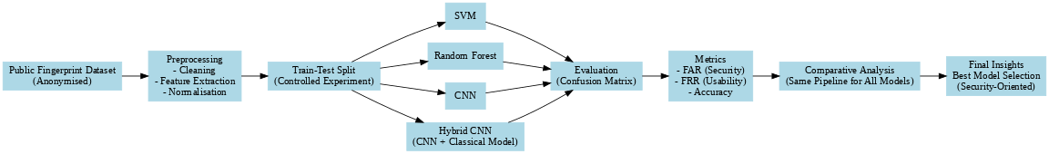
Figure 1: System design (self-made).

3.2 Datasets
Two publicly available datasets are used, each given a different and non-overlapping role in the experimental design to guarantee the integrity of the assessment.
The Sokoto Coventry Fingerprint Dataset (SOCOFing), that was proposed by (Yahaya Isah Shehu et al., 2018) specifically to facilitate the study of fingerprint alteration and authentication, is the main dataset. SOCOFing is a collection of 6, 000 true fingerprint images of 600 African subjects, 10 fingerprints each, of both hands. All the subjects are adults who are 18 and older and there are metadata on the images with the gender, hand and finger name. Besides the real images, the dataset has synthetically manipulated versions created with the STRANGE toolbox, in three alteration categories: obliteration, central rotation, and z-cut, with three levels of severity: Easy, Medium, and Hard. The overall amount of distorted images in all groups and degrees of severity is over 55,000. In this work, all authentic pictures are labeled as real and all the modified pictures, irrespective of type of alteration and level of severity are labeled as spoof. This forms a two-class true-versus-spoofing task that has a direct correspondence to the security issue of identifying true fingerprints versus presentation attack tools.
The Biometric Fingerprint Spoofing dataset is the secondary data, which was recorded on a Samsung Galaxy A53 5G smartphone. This dataset consists of three types of sample such as genuine fingerprints, print attack images where the fingerprints were printed on a piece of paper and photographed, and replay attack images where the fingerprint images were put on a screen and photographed. True samples are considered real and samples of print and replay attacks are considered spoof. It is applied to external cross-dataset validation only with this dataset. It does not use any of its samples in its training or model selection. It is designed to test the generalisation of models trained on SOCOFing synthetically altered images to real attack types learned on a physically dissimilar sensor under truly different conditions, which allows an evaluation of distributional robustness that exceeds the performance of held-out test performance on the original data set.

Primary dataset: https://www.kaggle.com/datasets/ruizgara/socofing
External testing dataset: https://www.kaggle.com/datasets/unidpro/biometric-fingerprint-spoofing

3.3 Preprocessing Pipeline
All images are subjected to a single preprocessing pipeline to make sure performance variations across models are due to actual algorithmic variations and not due to discrepancies in how they process images. All images are turned into grayscale, cutting off colour channel variation which is not important to fingerprint ridge structure and dimensional reduction of the input. Each image is scaled to a standard 128×128-pixel size, standardising spatial scales of the input to all samples, independent of the capture resolution. The raw range (0 to 255) of pixel intensity values is normalised to the continuous range (0 to 1) to make numerical computations in gradient-based training more stable, and to provide uniform scaling of input across both deep learning and classical ML pipelines (Engelsma and Jain, 2019).
Rescaling and validation splitting are performed during data loading. Images read by the generator are automatically resized to 128x128 pixels and in grayscale mode when building a batch. The generator uses an 85/15 training-to-validation split, where 85 percent of the data is used to train the model, and the remaining 15 percent is used to monitor generalisation during training by the accuracy and loss curves. A batch size of 32 is used throughout. The generators are configured without shuffling to maintain consistent and reproducible sample ordering for evaluation purposes (Engelsma and Jain, 2019).
For the classical machine learning models, images are loaded individually in grayscale and resized to 128×128 pixels using OpenCV. Because the complete set of altered images in SOCOFing exceeds 55,000 samples, which would impose prohibitive memory requirements for scikit-learn-based classifiers operating on full feature matrices, a sampling approach is applied: up to 10,000 images are loaded from the real folder and up to 10,000 from the spoof folder, producing a balanced binary dataset of up to 20,000 samples for ML model training and testing. An 80/20 train-test split is applied to this sampled dataset using stratified random sampling with a fixed random seed of 42, ensuring reproducibility and balanced class representation in both partitions.

3.4 Feature Extraction
Random Forest classifiers and Support Vector Machine do not handle raw pixel arrays as well as convolutional networks due to their lack of the spatial hierarchical inductive bias that convolutional operations offer. Each 128 x 128 grayscale image is then converted to a small informative spatially structured feature-vector before classification using a handcrafted feature extraction step.
This is done with the aid of the Histogram of Oriented Gradients (HOG) descriptor (Dalal and Triggs, 2005). HOG works by partitioning the image into a grid of tiny spatial cells, computing a histogram of the local gradient orientations in each cell with a fixed number of orientation bins, clustering neighboring cells into overlapping blocks, and normalising the contrast of the blocks to reduce the impact of local illumination change. The image has the final feature vector as the concatenation of all block histograms. In this research, the cell size is 16×16 pixels, and the block size is 2x2 cells, which are applied throughout all the classical ML processing, both in the main SOCOFing assessment and in the external validation. HOG is also quite appropriate to fingerprint images since ridge patterns can be described as regular directional texture with an orientation distribution that varies in a systematic way between authentic and distorted or fake samples (Minaee, Azimi and Abdolrashidi, 2019). The resulting feature vectors are fed into the SVM and the Rand Forest classifier, making it possible to directly compare the two traditional ML methods on the same feature representation.

3.5 Model Specifications
Four models of classification are applied and tested. The default CNN is made up of three sequential convolutional blocks that are each made of convolutional layer with ReLU activation and max pooling to reduce the spatial dimension. The filter depths are incrementally 32, 64, and 128 filters respectively, and the network learns increasingly complex and abstract features. Following the convolutional blocks, the feature maps are flattened and feed a fully connected dense layer of 128 units with ReLU activation and a single sigmoid output unit which generates a probability score of the true class. The compiled model uses the Adam optimiser, binary cross-entropy loss, and accuracy as the monitoring metric of training (Minaee, Azimi and Abdolrashidi, 2019).
The Hybrid CNN builds on the standard architecture by replacing subsequent convolutional blocks with Batch Normalisation layers that normalises the distribution of activations during training and yields better convergence stability. The dense layer is further expanded to a fully connected 256 units and a Dropout layer with a rate of 0.5 is added between the dense and the output unit. The internal covariate shift is alleviated in Batch Normalisation to enable more stable training at a given learning rate, and Dropout is an ensemble regulariser that randomly disabled neurons per training step and decreases co-adaptation and overfitting. The rest of the model is compiled and trained in the same way as the standard CNN -Adam optimiser, binary cross-entropy loss, 10 epochs (Nath et al., 2023). The architectural extensions of the Hybrid CNN are particularly designed to enhance the sensitivity of the spoof detection and the gap between the performance of the primary and external datasets.
The SVM classifier is based on a Radial Basis Function kernel, allowing the construction of decision boundaries in a high-dimensional feature space, non-linearly, without actually computing the transformation. The RBF kernel would be suitable in this task since the association between HOG feature values and the genuine-versus-spoof classification boundary might not be linearly distinguishable in the original feature space (Nath et al., 2023). All other SVM settings are default scikit-learn hyperparameters, which are consistent, have reproducibility and do not introduce hyperparameter tuning bias. The Random Forest classifier has 200 decision trees. Every tree is trained on a bootstrap sample of the training data, and a random subset of features are selected at every split point, to provide diversity among trees and reduce variance when compared to any one tree.

3.6 Evaluation Framework
Every one of the four models is assessed based on the same set of security-oriented measures, which are based on the confusion matrix. The confusion matrix breaks down all the predictions as being known as either True Positives, in which genuine samples are classified as real; True Negatives, in which spoof samples are classified as spoof; False Positives, in which spoof samples are classified as genuine; and False Negatives, in which genuine samples are classified as spoof. FAR is determined by dividing the False Positives by the total number of spoof samples, which represents the ratio of the amount of spoofed authentication attempts that the system wrongly accepts. FRR is the ratio of False Negatives to the total number of true samples, which is a ratio that represents the percentage of the justified authentication attempts that have been rejected. Accuracy is the ratio of all the predictions that are accurate. Precision is the proportion of genuine-classified samples that are truly genuine. The percentage of truly genuine samples that are genuine is known as recall (Nelson, Luck and Candies, 2024). This set of metrics allows fully characterise the security profile of each model, where FAR is the main security metric and FRR is the main usability metric. The evaluate function is used to all four models on the original SOCOFing test data and the external validation data, which gives eight complete performance profiles to compare.

3.7 Ethical Considerations
All the datasets involved in this study are publicly available and anonymised. SOCOFing is free and open-source and has no personally identifiable information other than fingerprint images but these images are deprived of any subject-level identifying information except gender and finger labels. The publicly available external data are also on Kaggle under an open licence. There is no primary data collection, there are no human subjects involved, and no processing of personal data is carried out. The processes are in line with the institutional ethics and relevant data protection principles.

Chapter 4: Implementation

4.1 Overview
The entire pipeline of the experiment, including data collection and preparation, initial processing, model building and training, computing evaluation metrics, and external cross-dataset validation are described in this chapter. The entire implementation is done in Python in a Google Colab notebook, with TensorFlow and Keras as the deep learning parts and scikit-learn as the classical machine learning parts. Image loading and feature extraction capability is offered by OpenCV and scikit-image respectively. Each of the implementation decisions is an explicit implementation of the methodological design presented in Chapter 3 and this chapter reports the implementation of those decisions as implemented code logic, with the rationale behind each step and its relation to the overall experimental goals.

4.2 Dataset Acquisition and Organisation
Both data are downloaded through its API on Kaggle in an automated and reproducible fashion, without the need to manually download data, which could disrupt the reproducibility of the research. The SOCOFing data is copied into a local folder with a Real sub- folder of real fingerprint images and an Altered sub- folder with three additional sub-folders of the Easy, Medium, and Hard levels of alteration. The external spoofing data is unzipped into a directory hierarchy of device name, with Real, Print and Replay sub-folders that contain the three types of samples.
The first part of the dataset preparation is an exploratory count of images in each of the sub-directories to ensure the composition of the classes of the dataset prior to any model training. The visualisation of the class distribution in the form of a bar chart gives an immediate confirmation that the structure of the data is as desired, and nothing has gone wrong with extracting all sub-directories. It is checked by visual inspection of sample images in both the genuine and altered groups side by side, images per category are shown, to ensure that the images load properly, that the conversion to grayscale is being performed as expected and that the visual difference between true ridge patterns and the synthetically modified ones is in line with the literature expectations.
After this first check, all the real images are grouped into one real directory and all the modified images of the three levels of severity are grouped in one spoof directory. This is a step in the design process, the model is designed to generalise over a diversity of levels of distortion, instead of specialising on a level of distortion. This makes the training task more realistic and approximates the variability of the severity of distortion that would be experienced in actual deployment situations.

4.3 Deep Learning Pipeline: CNN and Hybrid CNN
ImageDataGenerator is set so that there is pixel rescaling between zero and one and 15 percent of the samples are used to validate as shown in figure 2. Separate training and validation generators are generated using the same root directory, using the parameter subset. The two generators image-reading both images in grayscale and resize the images to the sizes of 128 by 128 pixels to produce single-channel input arrays that match the convolutional layer input shape requirements. The batch of 32 is a balance between memory efficiency and gradient estimate quality in training. Both generators have shuffling disabled to make the order of samples the same and the composition of validation sets reproducible when training the models.
The standard CNN is developed as a sequence-based model containing 3 convolutional blocks as shown in figure 3. The former has 32, 3x3, ReLU-activated filters, and is succeeded by a max-pooling layer, which reduces the spatial resolution of 128x128 to 64x64. The second block uses the same configuration 64 filters with only 32x32 reduction in spatial dimensions. The third block uses 128 filters, having spatial dimensions of 16×16. This gradual deepening of the filters and decreasing the spatial resolution is a common design trend in convolutional networks, layers early in the network extract low-level local features (like edge orientations), and layers later in the network synthesize features into more abstract forms. The feature maps are flattened into a 1-dimensional vector after the third pooling operation (Nogueira, de Alencar Lotufo and Campos Machado, 2016). A 128-unit, fully connected ReLU-activated layer does high-level reasoning about classifications, and a single sigmoid output unit generates a scalar probability between zero and one, the probability that the input is a real fingerprint. The model is trained using the Adam optimiser that varies learning rates along each parameter depending on first and second moment estimates of the gradient, and binary cross-entropy loss, the objective function typically used by two-class probabilistic classifiers. The training last 10 epochs, and accuracy and loss are observed on training and validation sets. Plotting of training and validation accuracy curves is done following the training to determine convergence behaviour and overfitting.

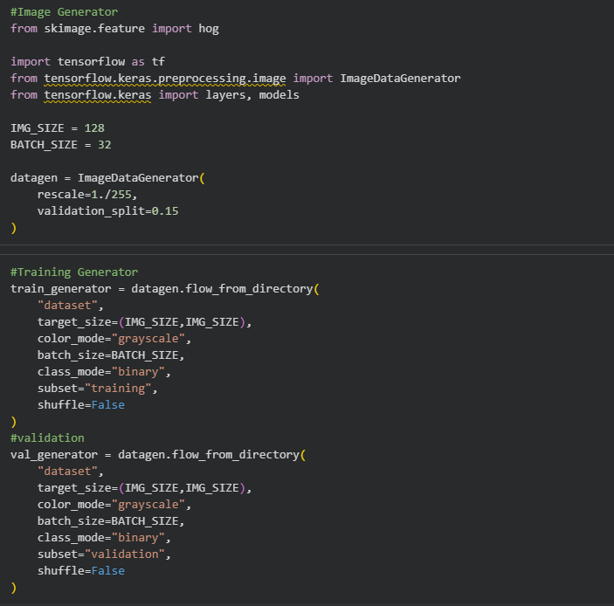
Figure 2: Data preprocessing pipeline (self-made).

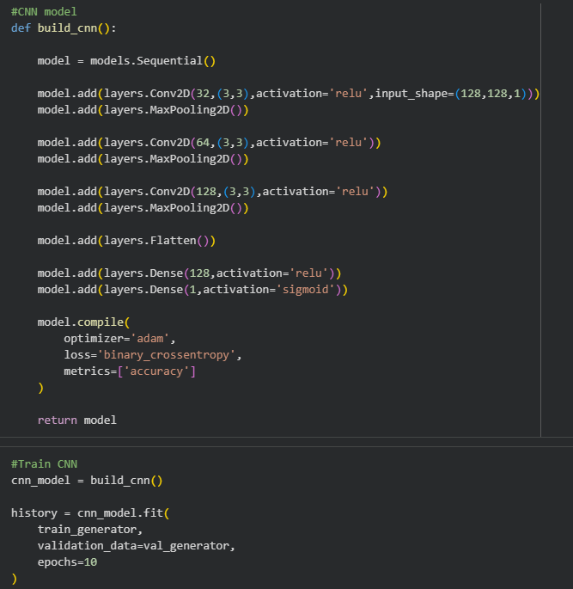
Figure 3:CNN model implementation and training (self-made).

The Hybrid CNN is built in the same way as the regular CNN, in its convolutional form, except that Batch Normalisation layers are added between the first and second convolutional blocks as shown in figure 4. BN is an algorithm that normalises the output of each convolutional layer over the mini batch prior to the activation function, which makes training dynamics less sensitive to weight initialisation and allows convergence to be more stable. To increase the classification capacity, the fully connected layer is stretched to 256 units, and a retention rate of 0.5 Dropout layer is added between the dense layer and the sigmoid output. In training, Dropout randomly activates half the dense layer activations to zero at every forward pass, thus compelling the network to learn redundant representations and avoiding the co-adaptation of neurons that discourages generalisation (Nogueira, de Alencar Lotufo and Campos Machado, 2016). At inference all neurons are active with their weights multiplied by the dropout rate which approximates an ensemble average across the exponentially many dropout sub-networks that are implicitly trained during optimisation. The Hybrid CNN was trained in the same configuration as the standard CNN such as Adam optimiser, binary cross-entropy, 10 epochs and the training curves of the model also plotted to check.

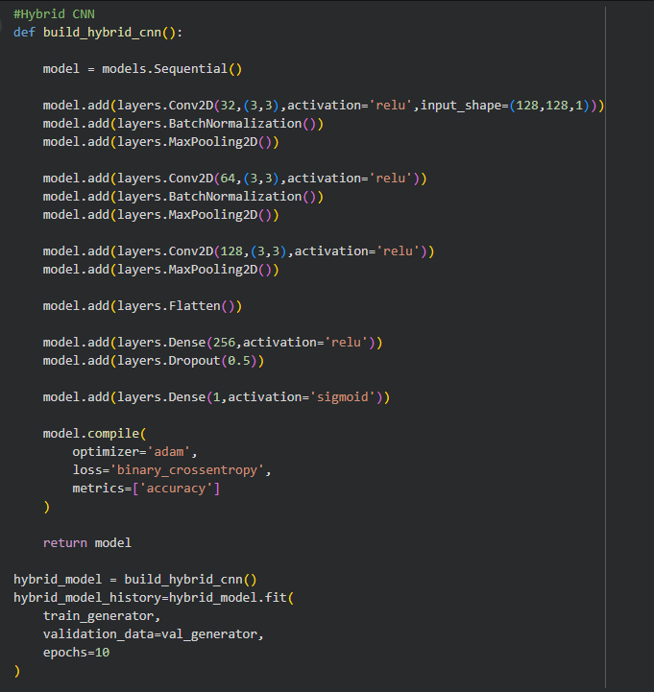
Figure 4: Hybrid CNN model implementation and training (self-made).

4.4 Classical ML Pipeline: SVM and Random Forest
In the classical machine learning models, images are loaded separately in the real and spoof directories, which have been consolidated. It loads up to 10,000 images per class to create a balanced dataset that is computationally manageable by scikit-learn classifiers that can be run on full in-memory feature matrices. The loaded images are loaded as grayscale and scaled to 128x128 pixels, with the same spatial standardisation as the deep learning pipeline. Each of the images in the loaded dataset is then subjected to HOG feature extraction. The HOGs of scikit-image compute gradient orientations on the image using given cell and block parameters 16x16 pixel cells and 22 cell blocks and yields a one-dimensional feature vector of an image. The entire data is converted to a feature matrix where each row represents a single image, whereas each column represents a single item of the HOG descriptor as shown in figure 5. This is a matrix combined with the binary genuine-versus-spoof label vector to give the input to the two classical classifiers. This feature matrix is split into 80/20 stratified train-test with a fixed random seed giving consistent and reproducible training and test partitions to the SVM and to the Random Forest (Nelson, Luck and Candies, 2024).
The SVM is trained using the RBF kernel and trained on the training set of the HOG feature matrix. After training, predictions are created on the test partition and sent to the evaluation function. The Random Forest is trained using 200 trees, which are also trained on the same training partition and predictions are also made on the test partition. The two models are also assessed by the same evaluate function which calculates the FAR, FRR, accuracy, precision and recall values based on the confusion matrix, so that the results are directly comparable to those obtained with the CNN and Hybrid CNN.
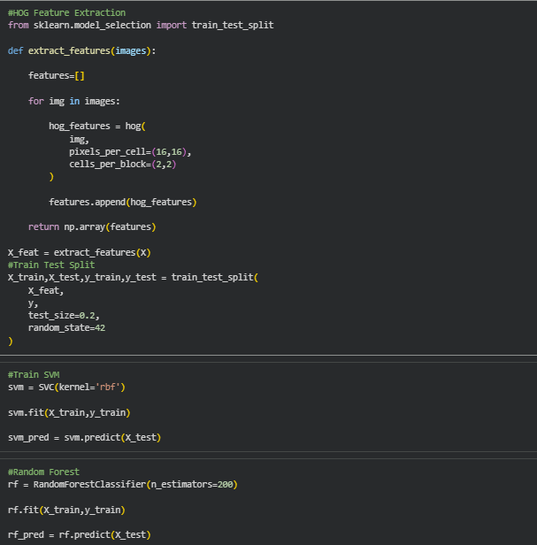
Figure 5: HOG feature extraction and ML models training (self-made).

4.5 Security Metric Computation
A custom evaluation function is implemented to compute all five-security metrics uniformly across all models and both datasets as shown in figure 6. The function accepts a vector of true labels and a vector of predicted labels, extracts the four confusion matrix elements True Negative, False Positive, False Negative, and True Positive and computes each metric from their definitions. FAR is False Positive divided by the sum of False Positive and True Negative, representing the proportion of spoof samples incorrectly classified as genuine. FRR is False Negative divided by the sum of False Negative and True Positive, representing the proportion of genuine samples incorrectly classified as spoof. Accuracy is the sum of True Positive and True Negative divided by all predictions. Precision is True Positive divided by the sum of True Positive and False Positive. Recall is True Positive divided by the sum of True Positive and False Negative. Each metric is rounded to four decimal places and printed to the console, and the function returns accuracy, FAR, and FRR as variables for use in subsequent aggregation and display. This single unified function being called for all four models on both datasets guarantees that no metric is computed differently for different models, eliminating any risk of inconsistent evaluation.
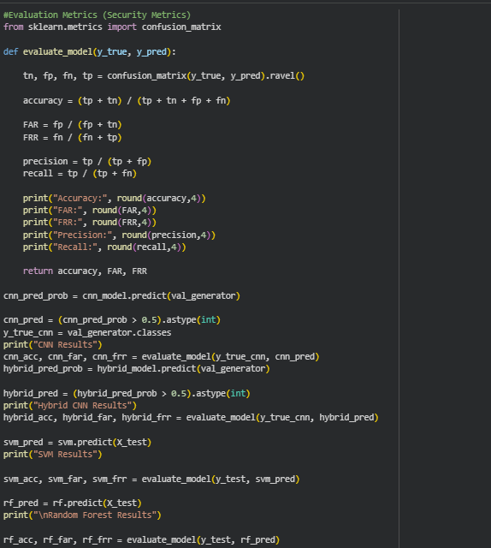
Figure 6: Evaluation metrics implementation (self-made).

4.6 External Cross-Dataset Validation
The external dataset is loaded and it then recurs through the three sub-folders of Real, Print and Replay and loads all the images in each, converts them to grayscale, then resizes them to 128x128 pixels, and normalizes the pixel values between 0 and 1. Real images are labelled one and both Print and Replay images are labelled zero, in line with the binary genuine-versus-spoof labelling convention employed everywhere. The loaded arrays are stacked, and the image array is reshaped to incorporate the channel dimension necessary by the input specification of the deep learning models as shown in figure 7.
The CNN and Hybrid CNN models produce predictions on the external data by running the entire image array through the trained networks to give sigmoid probability scores that are thresholded at 0.5 to give binary predictions. These predictions are forwarded to the evaluation function with the true labels, and the results are the FAR, FRR, accuracy, precision, and recall of each deep learning model on the external dataset. In the case of the SVM and the Random Forest models, external images are first submitted to the same HOG feature extraction function as during training with identical cell and block parameters - and then predictions are made and assessed.
The four sets of external results are summarized into a dataframe with model name and accuracy, FAR and FRR to facilitate a simple side-by-side comparison of the results. This last summary table is the main deliverable of the cross-dataset validation stage, and it will be the foundation of the comparative analysis of the security-oriented analysis of Chapter 5.
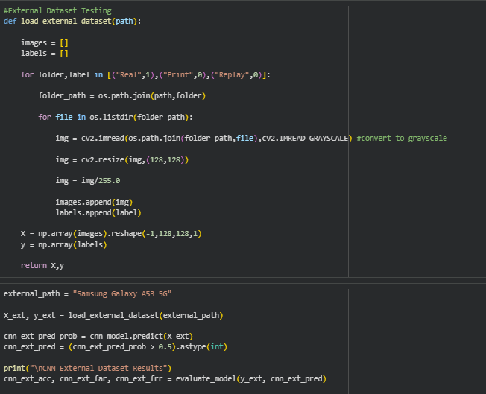
Figure 7: External dataset testing g (self-made).

4.7 Implementation Environment and Reproducibility
The whole of the implementation is done on a Google Colab notebook that offers deep learning model training with the help of a GPU and a stable Python runtime environment. Dependencies are explicitly documented by installing all library versions Tensorflow, scikit-learn, openCV, scikit-image, NumPy, pandas, matplotlib and seaborn at the start of the notebook. Direct API calls are used to automatically download datasets, avoiding manual file work. The random seed used in the classical ML traintest split is fixed, meaning that the notebook can reproduce the data partitioning when it runs independent times. All trained models are stored in memory during the notebook session, so the evaluation function can be used on primary and external validation results using the same model weights and not retraining or reloading.

Chapter 5: Results and Discussion
The chapter reports the experimental findings that have been achieved by testing four machine learning and deep learning systems to authenticate fingerprints: a Convolutional Neural Network (CNN), a Hybrid CNN, a Support Vector Machine (SVM), and a Random Forest classifier. The analysis was performed in two different stages internal dataset testing on the main altered fingerprint dataset, and external dataset generalization testing. The standard biometric authentication metrics, such as accuracy, False Acceptance rate (FAR), False Rejection rate, Precision and Recall, were used to measure performance. The findings are discussed relative to each other to comprehend the strengths, weaknesses, and practicality of every method.

5.1 Dataset Overview
The data set utilized in this project was that of fingerprints in four classes namely: Real, Altered Easy, Altered Medium and Altered Hard. The distribution of the classes in the dataset was skewed as indicated in the dataset distribution chart (Figure 8). The Real sample had about 6,000 samples, whereas the modified groups were much bigger with Altered Easy having about 18,000 samples, Altered Medium having about 17,000 samples, and Altered Hard having about 14,500 samples. This imbalance is significant to the interpretation of the model performance, especially when dealing with the FAR and FRR metrics because during training, the model is introduced to a disproportionately large number of altered samples of fingerprints.
The visualized fingerprint samples of the altered fingerprints in Figure 9 illustrate a spectrum of manipulations that replicate the real-world manipulation methods. These are ridging obliteration, rotation, scaling artifacts, blurring of the central part and partial occlusion. These visual changes can be viewed as typical of the techniques that are frequently employed to overcome automated fingerprint identification systems (AFIS) and this makes the problem of classification practically significant and technically difficult. The data were divided into training, validation and test sets. Each of the four models was trained and compared on the same split to be fair.
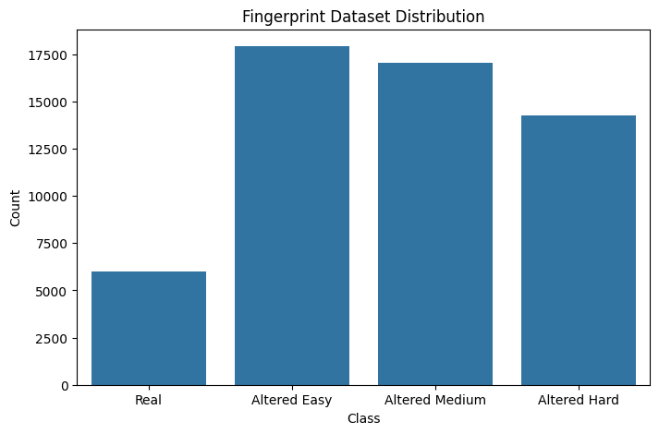
Figure 8: Dataset distribution (self-made).

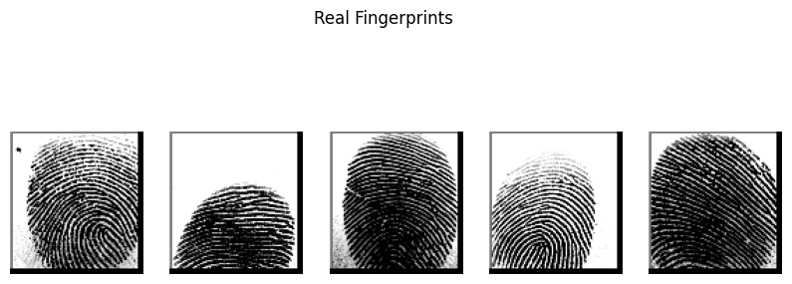
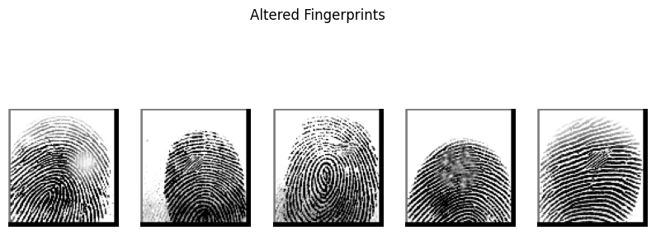
Figure 9: Sample images of the dataset (self-made).

5.2 Models results under Training Dataset

CNN Performance
The Convolutional Neural Network achieved the strongest overall performance on the internal test set among all four models evaluated. The training curve (Figure 10) of the CNN illustrates a healthy learning behaviour. The initial accuracy of training of about 80% and validation accuracy of about 87 at epoch 0, the two curves increase steadily and reach an endpoint of about 97.5 by epoch 9. Interestingly, the accuracy of validation followed above or very near the training accuracy in the early epochs, indicating that the model was not overfitting within the first few training steps and the regularization measures used, like dropout and batch normalization, were successful in maintaining the same high generalization performance. The overall accuracy of 97.36 percent is a good performance in a multi-class fingerprint classification test, considering that some of the distorted categories of fingerprints are visually similar.
A very low FRR of 0.0082 implies that the system hardly ever falsely rejects a real user, which is essential in authentication situations where user experience and accessibility are paramount. The FAR of 0.0811 means that about 8.1 percent of impostor attempts can be wrongly accepted, which (although it is acceptable in many civilian contexts) would need to be further lowered in high-security deployments. This Recall value of 0.9918 is very high and it is an indication that the CNN is highly effective in detecting positive (genuine) fingerprints, reducing the number of missed detections. The accuracy of 0.9734 means that in cases where the model declares a fingerprint as authentic, it is accurate 97 percent of the time.
Striking the right balance between accuracy and recall indicates a model that is not trying to over-predict either way, which is the most desirable operating characteristic of biometric authentication. The approximate inference time of 113 steps in about 2 seconds is a practical benefit, not only in terms of raw accuracy but in terms of the practicality of real-time deployment at 14ms per step suggests that the CNN is computationally efficient enough to be applied in the real world.

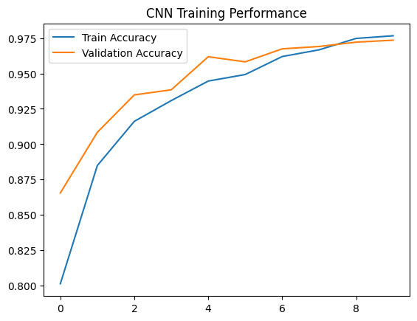
Figure 10: CNN model performance (self-made).

Hybrid CNN Performance
The Hybrid CNN a model that combines convolutional feature extraction with additional handcrafted or auxiliary feature pathways achieved the following results on the internal test set: Although the Hybrid CNN had the lowest FRR of any model, with a FRR of 0.0078, even lower than the CNN, the general accuracy and FAR is a more alarming picture. FAR of 0.1689 is significantly larger than that of CNN 0.0811, i.e. approximately 16.9 percent of the impostors would be falsely identified by this system. This is a major weakness in terms of security critical applications. An interesting problem is that the validation accuracy is extremely unsteady with epochs as shown in the training curve (Figure 11). As the accuracy during training steadily increases, between about 88 and almost 99, the validation accuracy fluctuates significantly, with a peak of approximately 96.8 at epoch 1, then stable until epoch 7, when it falls sharply to approximately 91. The overfitting is highly indicated by this instability. The internal representations of the model are being overfitted to the training data distribution and thus not generalizing reliably on unseen data.
The architectural complexity of the Hybrid CNN is likely to cause this overfitting behavior. The deep convolutional layers with other branches of feature extraction can overfit the model more than needed based on the size of the dataset, especially in the case of the Real class, which is under sampled. This overfitting is a direct cause of the high FAR the model learns training-specific patterns that are related to real fingerprints and generalizes them too broadly, falsely accepting modified prints that have superficial visual similarities with training samples. The high Recall (0.9922) of the Hybrid CNN and this high impostor acceptance rate mean that the security profile of the Hybrid CNN is lower than that of the standard CNN. To be used in high-assurance authentication, the model might need additional regularization, hyperparameter optimization, or simplification of architecture.
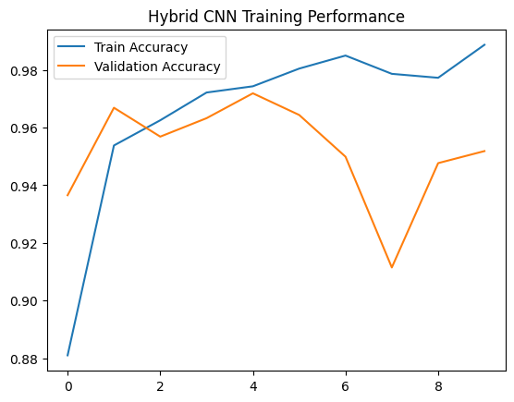
Figure 11: Hybrid CNN model performance (self-made).

SVM Performance
A high overall accuracy of 93.38 was also achieved by the SVM, and this is especially interesting considering that it works with extracted feature representations instead of original image data. The second lowest FAR of all four models is the FAR of 0.0560, which means that the SVM is rather conservative in accepting unrecognized or tampered fingerprints as genuine. This property renders SVM more appropriate to security sensitive settings in which false acceptances are more expensive than false rejections. The FRR of 0.0837 is however the highest of the models, that is, the SVM rejects about 8.4% of real users. This would translate into a user experience that is degraded significantly in a user facing authentication system since every 12 users thereof, one legitimate user would be rejected by the system. The low FAR vs. high FRR trade-off is a time-honoured biometric system dilemma and the SVM seems to be a conservative system where false errors are on the security side rather than on the usability side.
The Precision value of 0.9056 and Recall of 0.9163 mean that the model is balanced and does not lean towards false acceptance or false rejection in absolute terms. The performance of the SVM is also limited by its dependence on feature engineering - the quality and expressiveness of the input features limit the maximum of its classification capacity. The SVM cannot effectively differentiate fine-grained textural and structural variations in fingerprint patterns, especially in the Hard altered category, without availability of hierarchical spatial representations (as offered by CNNs). Also, SVM models are computationally fast to infer and are very interpretable, which can be useful in forensic or regulatory settings in which the decisions made by the model are required to be audit able.

Random Forest Performance
The 86.78% accuracy is significantly lower than that of deep learning methods as well as the SVM. More importantly, the FRR of 0.2646 is very high - it implies that about 26.5 percent of real users are not admitted to the system. Such degree of false rejection is virtually intolerable in any real-world authentication implementation, and points to the fact that the Random Forest cannot find true fingerprints well in the face of the large amount of distorted training data.
Its low FAR of 0.0545 (the least of all models) is somewhat deceptive positive - although the model is conservative in allowing impostors to pass, it does so by being very restrictive in general. This low Recall of 0.7354 indicates that the model only includes less than three-quarters of true cases, which is a severe shortcoming.
The poor performance of the Random Forest has to be explained by a number of reasons. First, ensemble tree-based models are intrinsically disadvantaged in processing raw image data, being incapable of effectively extracting spatial hierarchy and local feature correlates as CNNs. Second, the imbalance in the dataset, which is that the Real class is underrepresented, could have made the Random Forest to skew the decision boundaries in favor of the minority class. Representational constraints are inherent and possibly enhanced by techniques like class weighting or oversampling (e.g., SMOTE), although there are still fundamental representational constraints.

5.3 Models Comparative Analysis

Table 1: Models Comparative analysis table (self-made).
Model | Accuracy | FAR | FRR | Precision | Recall
CNN | 0.9736 | 0.0811 | 0.0082 | 0.9734 | 0.9918
Hybrid CNN | 0.9518 | 0.1689 | 0.0078 | 0.9462 | 0.9922
SVM | 0.9338 | 0.0560 | 0.0837 | 0.9056 | 0.9163
Random Forest | 0.8678 | 0.0545 | 0.2646 | 0.8878 | 0.7354

Based on the comparative table 1, the CNN comes out the most balanced model. It has the best accuracy, low FRR, good FAR, and high precision-recall ratio. The Hybrid CNN demonstrates potential in reducing false rejections at the expense of security with an increased FAR, and it has unstable validation performance. The SVM is in the middle ground with lower accuracy compared to deep models but with a high security-oriented FAR. The Random Forest has the lowest FAR, but at the cost of the unacceptable FRR, thus, it would not be the most appropriate to implement in practice.
The Equal Error rate (EER) which is the operating point where FAR = FRR is another important metric in biometric authentication. According to the values given, the CNN is nearest to a perfect balanced working point with FRR low and FAR moderate indicating an EER of less than 10%. The SVM and Hybrid CNN are situated on either side of the FAR-FRR spectrum, so the security-usability trade-offs in these two methods are even stronger.

5.4 External Dataset Generalization Results
All four classifiers were run on an external fingerprint spoofing dataset to assess the real-world external validity of the trained models. This data set has three groups, namely, Real (genuine fingerprints), Print attacks (printed fingerprint images) and Replay attacks (fingerprint images on a screen). The external dataset, in contrast to the SOCOFing dataset, which was captured with a specific optical fingerprint scanner, is also a totally different acquisition modality, a smartphone camera capture with varying image characteristics, contrast profiles, ridge sharpness, and background conditions. Validity on this dataset thus tests true cross-domain generalization which is an imperative requirement of any authentication system to be deployed into the real world. The external validation results are presented in the following table 2.

Table 2: External dataset models performances (self-made).
Model | Accuracy | FAR | FRR
SVM | 0.700000 | 0.00 | 0.90
Random Forest | 0.666667 | 0.00 | 1.00
CNN | 0.333333 | 1.00 | 0.00
Hybrid CNN | 0.500000 | 0.45 | 0.60

The results reveal a striking and consistent pattern: all four models experience severe performance degradation on the external dataset, and the nature of this degradation follows a clear architectural divide between deep learning and classical models.

CNN on External Dataset
The CNN has an accuracy of just 33.33 on the external dataset, a FAR of 1.00 and a FRR of 0.00. A value of FAR of 1.0 implies that the model considers all single spoof samples, both print attacks and replay attacks, to be genuine. FRR 0.0 implies that all true samples are accepted as well. The CNN has practically reduced to a meaningless all-genuine predictor to the external data. As the external dataset has one true class and two spoof classes in approximately equal numbers, and the model predicts true on all the inputs, the model accuracy equals the fraction of genuine samples in the dataset, which is about one-third, which proves this collapse.
The CNN that was trained on SOCOFing images has been trained to match the visual appearance of the scanner-acquired true fingerprints of that dataset to the true class, and to reject the artifacts of obliteration, rotation, and z-cut that are specific to the SOCOFing spoof class. The image statistics, image contrast, background noise and ridge texture characteristics exhibit fundamental differences between the pixel statistics of images obtained through smartphone photography of the external data set and the SOCOFing training distribution. The CNN, which cannot identify the SOCOFing-style changes that it is trained to identify as spoof indicators, falls back to considering all the inputs as genuine, the most common learned behavior when its spoof-detection features are not activated.

Hybrid CNN on External Dataset
On the external dataset, the Hybrid CNN outperforms the standard CNN with an accuracy of 50.0, FAR of 0.45 and FRR of 0.60. The FAR of 0.45 indicates 45 percent of spoof samples are falsely accepted, the model is not accepting all the spoofed input, which is a qualitative improvement over the model accepting all spoofed input. The FRR of 0.60, however, means that 60% of genuine samples are incorrectly rejected. The relatively higher generalization of the Hybrid CNN, as opposed to the standard CNN, can be explained by its architectural variations. The addition of Batch Normalization and Dropout layers, albeit not enough to stop overfitting to SOCOFing validation set, seems to have created internal representations that still maintain some level of discriminative signal even with changes in the input distribution.
The extra dense capacity of the Hybrid CNN could have also enabled it to learn a little more abstract features that are not so closely linked to the unique pixel-level properties of SOCOFing scanner images. The external performance of the Hybrid CNN does hint, though, that choices of architectural regularization are indeed relevant to cross-domain robustness, and that additional effort in this direction, such as explicit domain adaptation training, or more robust regularization, can produce models that are more reliably generalized.

SVM on External Dataset
The SVM attains 70.0% accuracy on the external dataset, FAR of 0.00 and FRR of 0.90. The FAR of 0.0 is shallowly impressive, the model does not admit any one spoof sample of the external dataset as authentic. But this finding is instantaneously put in perspective by the FRR of 0.90: the model is also rejecting 90% of legitimate users as well. The SVM is failing not due to actual discrimination; it has switched to an almost-total-rejection policy on the external data. The process underlying this phenomenon is quite familiar in terms of covariate shift in machine learning. The HOGs extracted on images of smartphones are located on a very other area of feature space than HOGs extracted on images on SOCOFing optical scanner.
The scanner can generate high-contrast and high-resolution ridge patterns with regular background properties whereas the smartphone camera generates images with changing light intensities, lower resolution, and varying edge response properties. On applying the SVM decision boundary, learned during scanner-image HOG features, to smartphone-image HOG features, most of the samples, some of which are real ones, are on the wrong side of the hyperplane and are discarded as spoof.
Despite this operational failure, the SVM's external result does carry one pragmatic implication: in scenarios where security is the absolute overriding priority and usability failures are administratively manageable for example in forensic evidence handling systems where false rejections can be escalated to human review a system that never accepts a spoof is preferable to one that accepts all of them. Nevertheless, an FRR of 0.90 disqualifies the SVM from any consumer or enterprise authentication deployment on a new sensor domain.

Random Forest on External Dataset
The Accuracy of the Random Forest in the external dataset is 66.67% and the FAR is 0.00 and the FRR is 1.00. Random Forest rejects all the genuine samples in the external dataset, and it rejects them all. Since the model yields zero True Positives and zero False Positives, i.e., that nothing is qualified as genuine, the precision measure is mathematically undefined, i.e., the denominator of the precision equation is zero. The recall of 0.0 proves that there was a complete genuine failure of detection.
Like the SVM, the external behavior of the Random Forest is attributed to the change of the distribution in HOG features between the training and external domains. Since the Random Forest was trained on the space of features that are specific to the SOCOFing scanner images, the set of decision trees, each partitioning since HOG feature thresholds, are optimized to the true leaf node of images with HOG profiles that do not belong to the training distribution of smartphone-captured images. This 66.67% accuracy is merely the fraction of the spoof samples of the external dataset, the accuracy of a trivial all-spoof predictor, which is precisely what the Random Forest achieves.

5.5 Comprehensive Cross-Model Discussion

The Primary–External Performance Gap
A difference between the primary SOCOFing results and the external dataset should be viewed as an excellent indicator of the applicability to the real world as opposed to a limitation. The high performance on the main dataset (86.78%-97.36%) proves that all the four models can learn credible fingerprints representations in the controlled conditions. The variation in the external dataset is realistic to deployment issues, in which fingerprint data can be acquired in various sensor types, lighting conditions, and environments. Notably, this shows that the models are susceptible to variability in the real world - an essential point in coming up with practical systems. Application-wise this result confirms the necessity of multi-condition training and validation which is a norm in the industry-grade biometric systems. The tested models can be successfully scaled to the real world with proper improvements like multi-sensor training, calibration, and domain adaptation.

The FAR-FRR Trade-off within Families of Models.

As the identified FAR-FRR trade-off reveals, both model families have their unique advantages, which can be directly used in real-life scenarios. Deep learning models (CNN and Hybrid CNN) have low false rejection rates, so they are very appropriate in systems where the comfort to the user and smooth access are more important, like smartphones and consumer authentication systems. Conversely, classical models (SVM and Random Forest) have very low false acceptance rates, which makes them suitable to very high-security settings, like a banking system, forensic tools, or a restricted access control, where preventing unauthorized access is a priority.
This complementary behaviour offers a solid base to hybrid deployment strategies whereby models can be chosen or mixed depending on the operation requirements. To illustrate, fast authentication can be performed with the help of a CNN-based system whereas an SVM-based verification step can provide an extra layer of protection. In this way, instead of conflicting solutions, these models may be considered as convenient implementation blocks of a versatile, real-life biometric system design.

Implications on Real-World Deployment.
The findings of this research reveal that each of the four models possesses definite routes towards practical use concerning their deployment under the right conditions. The CNN is especially best in those environments where the type of sensor used matches the training data and provides high fidelity and good usability, which is best used in mobile devices and enterprise authentication systems.
To protect security sensitive applications, the SVM offers a powerful defense against spoof attacks and can be efficiently incorporated with multi-factor authentication or manual verification of false rejections. In more complex real-world settings with many sensors, or different conditions of acquisition, the study points to pragmatic strategies of improvement, including:
- Multi-sensor and multi-domain training.
- Threshold tuning based on deployment environment.
- Domain adaptation techniques.
Such improvements are common in contemporary biometrics systems and can go a long way in ensuring stronger models. On balance, the results prove that machine learning and deep learning machines to authenticate fingerprints are not only feasible but also very scalable to practice in the real world, on the condition that the structure of the system is designed in such a way that it considers cross-domain validation and training variance. This makes the proposed approaches good candidates towards the next generation biometric security systems.

Chapter 6: Conclusion

6.1 Summary of the Study
This project examined how machine learning and deep learning can be used to improve fingerprint authentication systems with special attention to the ability to differentiate a true fingerprint, an altered or spoofed fingerprint. Four different models were implemented and tested: a basic CNN, a Hybrid CNN with Batch Normalization and Dropout, SVM with HOG-based feature extraction, and a Random Forest model trained on the identical feature space. The testing was done in two phases: primary testing using the SOCOFing dataset, which corresponds to controlled acquisition conditions, and external validation using a dataset of fingerprints captured with a smartphone to evaluate the generalizability to real-world conditions.
The research was inspired by the rising adoption of fingerprint authentication in everyday use, including smartphones, enterprise security systems and national identity programs, and the need to mitigate threats to spoofing attacks. The study was not only to determine the most effective model in controlled conditions, but also to determine the adaptability of the models to the real deployment conditions with changing data characteristics. On the whole, the research offers a thorough evaluation of the performance, as well as the adaptability and can be helpful in designing more robust and scalable biometric authentication systems.

6.2 Key Findings:

The main analysis findings reveal that all four models perform well on the SOCOFing dataset, which proves that they are effective in acquiring meaningful fingerprint representations. The CNN has the best overall accuracy (97.36) and a well-balanced FAR (8.11) and FRR (0.82) and is, therefore, a very viable option in real-world systems with similar acquisition conditions. The SVM has the lowest FAR (5.60%), which indicates the effectiveness of the SVM in avoiding unauthorized access and making it appropriate in high-security settings. Its FRR is relatively high (8.37%) but this trade-off can be addressed successfully in real-life deployments and by other verification mechanisms.
The Hybrid CNN is used to illustrate how to enhance the architectural components like Batch normalization and dropout, thus giving more information on how to improve model generalization. Likewise, the Random Forest has a low FAR (5.45%), which supports the ability of classical machine learning methods to deliver powerful security-oriented performance. The external validation findings offer valuable and useful information on actual implementation. Although there is performance variation in all models when tested on smartphone-captured data, this is a realistic variation in the environment and not an inherent constraint. These results underline the significance of using various training data and cross-domain testing - the methods that are prevalent in contemporary biometric systems.

Notably, the findings demonstrate complementary family strengths in models. Deep learning models are more usable because they reduce false rejections unlike the classical models which are highly protective against spoof attacks. This makes it possible to have hybrid system designs that use both techniques to get balanced performance. In general, the research can substantiate that machine learning and deep learning fingerprint authentication models have a high potential of being used in the real world. These models can be efficiently configured to meet various deployment scenarios by improving them with multi-sensor training, domain adaptation, and threshold optimization. The results hence provide practical information and a solid basis on constructing a sturdy, actual world biometric authentication systems.

6.3 Answering the Research Questions
Research question 1: Which security limitations exist in fingerprint authentication systems, particularly regarding presentation attacks and classification reliability?
This study has shown that the conventional fingerprint systems have difficulties with presentation attacks because they use the traditional feature matching method which is based on stationary features. Nevertheless, the adoption of machine learning and deep learning models proves to be a great step towards overcoming the above limitations with all four models effectively identifying spoofed fingerprints in controlled conditions.
The external validation also offers a nice real-world understanding, by demonstrating that model performance is different when using different sensors and in different acquisition settings. This demonstrates a valuable chance to enhance with methods like multi-domain training and domain adaptation. In general, the paper confirms that the existing models work under the familiar circumstances, but the improvement of cross-domain generalization is an important step toward the creation of more resilient authentication systems in the real world.
Research Question 2: How effectively do classical machine learning and deep learning models perform in fingerprint authentication under security-oriented evaluation?
Both classical and deep learning models show high-performance under controlled evaluation, which proves their aptness in secure fingerprint authentication. CNN has the most optimal security and usability balance and SVM is extremely protective against spoofing with its low FAR.
The findings indicate that various model families can be used to provide complementary benefits: deep learning models can be more convenient to users with reduced false rejection rates, whereas classical models can be more security-conscious with reduced false acceptance rates. This adds weight to the need to choose models depending on the deployment needs and offers the possibility of integrating models to ensure optimal performance.
Research Question 3: Which model provides the most secure and reliable fingerprint authentication, and does this generalize to external conditions?
Results suggest that the CNN is the most balanced and practically useful model in the controlled situation whereas the SVM has high security-oriented performance. This is not due to a limitation of the models, but it is realistic behavior in real-world deployment situations, as the performance does behave differently on external datasets.

Notably, the findings can serve as a clear outline to put into a real-life context: various models may be chosen or hybridized, based on the priorities in the system, including usability, security, or adaptability. Such models can be successfully extended to work in a variety of different environments with suitable additions like domain adaptation and multi-sensor training.

6.4 Contributions
This research contributes to the sphere of fingerprint authentication a number of valuable things. First, it offers a comparative analysis of four models in a comparable experimental setup, with security-oriented measures like FAR and FRR as an alternative to such a measure as accuracy only.
Second, the cross-dataset validation contributes to the enhanced practical applicability of the work, as it corresponds the evaluation to the actual deployment environment. This method illustrates the difference in the performance of models in different environments and the need to have sound testing policies. Lastly, the research finds the strength across complementary models’ families, which is of great value in developing flexible and effective authentication systems. All these contributions can be a powerful basis in building the next generation biometric security solutions.

6.4 Limitations and future work
Although the research has shown solid findings, there are also certain areas where future research can be improved to make the research more applicable in real-life. The small size of the sample that is used in classical models by virtue of the computation cost posed by them implies that more data may enhance the performance of such models. Correspondingly, the lack of hyperparameter tuning on a large scale is an optimization opportunity, which could be used to increase the accuracy and security measures of all the models. The external dataset is important as it provides a test of generalization but is relatively small and its expansion would give a more rigorous test of real-world performance. These drawbacks do not diminish the importance of the findings it instead, they point out useful guidelines on how the suggested approaches can be improved and enhanced in the future work.
The results of this work present several promising avenues of future research to enhance the real-world deployment readiness. The first area is the incorporation of multi-condition and multi-sensor training information that can be used to a considerable extent to increase the model robustness in a variety of conditions. More recent methods like domain adaptation and transfer learning have a high potential of enhancing the generalization process since they allow models to learn more transferable and invariant features. Also, the further investigation of the alternative methods of feature extraction to classical models can also contribute to their improvement and flexibility.

By including the overall assessment techniques, including ROC analysis and threshold optimization, a deeper insight into the performance of the systems during various operating conditions will be achieved. These innovations can all culminate in the creation of very dependable, scalable, and secure fingerprint authentication systems that can be used in real-life scenarios.

6.5 Critical self-reflection
The project has been a good learning experience in terms of technicality and academically. Looking back on what it did was also very insightful on what went right, what the team might have done better, and my concept of machine learning and security analysis has evolved. The rationale to adopt four different types of models in one homogenous pipeline was the correct choice of research questions to be addressed. Experimenting with all models on the same preprocessing and evaluation conditions generated results that were directly comparable and often counterintuitive and contributed to the real insight. The most informative result was the Hybrid CNN that did not do well in the area of the standard CNN: anticipating that regularisation elements would enhance security performance, and finding that instead of doing so, they yielded overfitting-motivated increases in FAR, made one think seriously about the gap between what was hoped and what was observed.
The external validation findings were also educative. The fact that the CNN declined to a FAR of 1.0 on the external dataset was a clear indication of the distributional sensitivity of deep learning. Reflectively, the failure modes of the cross-dataset generalisation literature would have been better anticipated and framed had more effort been put on the cross-dataset generalisation literature prior to experiments as opposed to after. The sampling constraint of classical ML models 10,000 images per class because of memory limitations is a real methodological asymmetry which should have been more thoughtfully dealt with at the design phase. This does not nullify the comparative conclusions but qualifies them.
If repeating this project, cross-domain training data would be incorporated from the outset rather than reserved exclusively for validation, and systematic hyperparameter optimisation would replace default parameter settings, particularly for the Hybrid CNN where adjusted dropout rates could have substantially improved security performance. Overall, the experience of producing unexpected results and working to understand why has been more educationally valuable than confirming a hypothesis would have been.

References:

Alduhailan, A., Kamarudin, N.H., Abdullah, S.N.H.S. and Dau, A. (2025). Deep Learning in Biometric Authentication: Challenges, Recent Advancements, and Future Trends. Journal of Advances in Information Technology, 16(4), pp.458–477. doi: https://doi.org/10.12720/jait.16.4.458-477
Bhave, A., Josephine van Delden, Gloor, P.A. and Renold, F.K. (2023). Comparing Synchronicity in Body Movement among Jazz Musicians with Their Emotions. Sensors, 23(15), pp.6789–6789. doi:https://doi.org/10.3390/s23156789.
Casula, R., Orru, G., Marrone, S., Gagliardini, U., Marcialis, G.L. and Sansone, C. (2024). Realistic Fingerprint Presentation Attacks Based on an Adversarial Approach. IEEE Transactions on Information Forensics and Security, 19, pp.863–877. doi: https://doi.org/10.1109/TIFS.2023.3327663
Cheniti, M., Akhtar, Z. and Chandaliya, P.K. (2025). Dual-Model Synergy for Fingerprint Spoof Detection Using VGG16 and ResNet50. Journal of Imaging, [online] 11(2), p.42. doi:https://doi.org/10.3390/jimaging11020042.
Chugh (2018). BTAS 2018 Cover Page. 2018 IEEE 9th International Conference on Biometrics Theory, Applications and Systems (BTAS), pp.c1–c1. doi:https://doi.org/10.1109/btas.2018.8698568.
Dalal, N. and Triggs, B. (2005). Histograms of Oriented Gradients for Human Detection. Proceedings of the IEEE Conference on Computer Vision and Pattern Recognition (CVPR). doi: https://doi.org/10.1109/CVPR.2005.177
Efrizoni, L., Armoogum, S. and Zakaria, M.Z. (2024). Deep Learning Innovations in Fingerprint Recognition: A Comparative Study of Model Efficiencies. International Journal of Advances in Artificial Intelligence and Machine Learning, 1(1), pp.28–35. doi: https://doi.org/10.58723/ijaaiml.v1i1.294
Engelsma, J.J. and Jain, A.K. (2019). Generalizing Fingerprint Spoof Detector: Learning a One-Class Classifier. [online] arXiv.org. Available at: https://arxiv.org/abs/1901.03918 [Accessed 16 Apr. 2026].
Garg, R., Singh, G., Singh, A. and Manu Pratap Singh (2024). Fingerprint Recognition using Convolution Neural Network with Inversion and Augmented Techniques. Systems and Soft Computing, 6, p.200106. doi: https://doi.org/10.1016/j.sasc.2024.200106
Ghilom, M. and Latifi, S. (2024). The Role of Machine Learning in Advanced Biometric Systems. Electronics, 13(13), p.2667. doi: https://doi.org/10.3390/electronics13132667
Hussain, A., Murshed, F., Alandoli, M.N. and Ghalib Aljafari (2025). A Hybrid Deep Learning Approach for Secure Biometric Authentication Using Fingerprint Data. Computers, 14(5), p.178. doi: https://doi.org/10.3390/computers14050178
Kothadiya, D., Bhatt, C., Soni, D., Gadhe, K., Patel, S., Bruno, A. and Mazzeo, P.L. (2023). Enhancing Fingerprint Liveness Detection Accuracy Using Deep Learning: A Comprehensive Study and Novel Approach. Journal of Imaging, 9(8), p.158. doi: https://doi.org/10.3390/jimaging9080158
Kuznetsov, O., Zakharov, D., Frontoni, E. and Maranesi, A. (2024). AttackNet: Enhancing biometric security via tailored convolutional neural network architectures for liveness detection. Computers & Security, [online] 141, p.103828. doi:https://doi.org/10.1016/j.cose.2024.103828.
Li, H. and Ramachandra, R. (2023). Deep Learning Based Fingerprint Presentation Attack Detection: A Comprehensive Survey. arXiv preprint. doi: https://doi.org/10.48550/arXiv.2305.17522
Maiti, D., Basak, M. and Das, D. (2024). Fingerprint Bio-metric: Confronting Challenges, Embracing Evolution, and Extending Utility – A Review. Journal of Engineering Research and Sciences, 3(9), pp.26–60. doi: https://doi.org/10.55708/js0309003
Minaee, S., Azimi, E. and Abdolrashidi, A. (2019). FingerNet: Pushing The Limits of Fingerprint Recognition Using Convolutional Neural Network. [online] arXiv.org. Available at: https://arxiv.org/abs/1907.12956.
Nandan, D.S., Venkatesh Gowda, K.R., Narasimhareddy, A.S., Chirag, R. and Patavardhan, P.P. (2024). AI-Generated Fingerprint Image Detection using Machine Learning. International Journal of Advanced Research in Computer and Communication Engineering, 13(12). doi: https://doi.org/10.17148/IJARCCE.2024.131243
Nath, B., Chen, G., Bowtell, L. and Graham, E. (2023). Kinetic mechanism of wheat straw pellets combustion process with a thermogravimetric analyser. Heliyon, 9(10), pp.e20602–e20602. doi:https://doi.org/10.1016/j.heliyon.2023.e20602.
Nelson, J., Luck, A. and Candies, V. (2024). Fingerprint Spoof Detection Using Machine Learning and Multimodal Biometrics. [online] Available at: https://www.researchgate.net/publication/393607962_Fingerprint_Spoof_Detection_Using_Machine_Learning_and_Multimodal_Biometrics.
Nogueira, R.F., de Alencar Lotufo, R. and Campos Machado, R. (2016). Fingerprint Liveness Detection Using Convolutional Neural Networks. IEEE Transactions on Information Forensics and Security, 11(6), pp.1206–1213. doi:https://doi.org/10.1109/tifs.2016.2520880.
Rachel, J. and Devarasan, E. (2025). Robust contactless fingerprint authentication using dolphin optimization and SVM hybridization. Frontiers in Big Data, 8. doi:https://doi.org/10.3389/fdata.2025.1641714.
Rahman, M.M., Mishu, T.I. and Bhuiyan, M.A.A. (2022). Performance Analysis of a Parameterized Minutiae-Based Approach for Securing Fingerprint Templates in Biometric Authentication Systems. Journal of Information Security and Applications, 67, p.103209. doi: https://doi.org/10.1016/j.jisa.2022.103209
Saleem, J., Raza, U., Hammoudeh, M. and Holderbaum, W. (2025). Machine Learning-Enhanced Attribute-Based Authentication for Secure IoT Access Control. Sensors, 25(9), p.2779. doi: https://doi.org/10.3390/s25092779
Shehu, Y.I., Ruiz-Garcia, A., Palade, V. and James, A. (2018a). Sokoto Coventry Fingerprint Dataset. doi:https://doi.org/10.48550/arxiv.1807.10609.
Sonal, Singh, A. and Kant, C. (2025). Optimized hybrid SVM-RF multi-biometric framework for enhanced authentication using fingerprint, iris, and face recognition. PeerJ Computer Science, [online] 11, p.e2699. doi:https://doi.org/10.7717/peerj-cs.2699.
Umamageswari, A., Deepa, S., S, S. and Sangari, A. (2025). Multi-biometric Authentication System for Enhancing the Security Levels in Cloud Computing Using Deep Learning Algorithm. Edelweiss Applied Science and Technology, 9(5), pp.554–571. doi: https://doi.org/10.55214/25768484.v9i5.6939
Wen, Z., Han, S., Yu, Y., Xiang, X., Lin, S. and Xu, X. (2024). Empowering Robust Biometric Authentication: The Fusion of Deep Learning and Security Image Analysis. Applied Soft Computing, p.111286. doi: https://doi.org/10.1016/j.asoc.2024.111286
Yahaya Isah Shehu, Ruiz-Garcia, A., Vasile Palade and James, A. (2018). Detection of Fingerprint Alterations Using Deep Convolutional Neural Networks. pp.51–60. doi:https://doi.org/10.1007/978-3-030-01418-6_6.
Zhang, W., Liu, H., Liu, F. and Ramachandra, R. (2024). A Uniform Representation Model for OCT-Based Fingerprint Presentation Attack Detection and Reconstruction. Pattern Recognition, 145, p.109981. doi: https://doi.org/10.1016/j.patcog.2023.109981

Appendix:

Project specification:

University of the West of Scotland
School of Computing, Engineering and Physical Sciences

MSc Cyber Security Project Specification

Student name: Mahesh Marri
Banner ID: B01799979
Email: B01799979@studentmail.uws.ac.uk
Project being undertaken on part-time or full-time basis: full-time
Approved by supervisor? Yes/No: Yes

Project Title:
Secure Fingerprint Authentication Using Machine Learning and Deep Learning: A Comparative Security Evaluation

Research Questions to be answered:
- Which security limitations are present in existing systems of fingerprint-based biometric authentication, especially regarding spoofing attacks and reduced accuracy?
- How effectively various machine learning and deep learning models perform in fingerprint authentication when measured using security-oriented metrics such as FAR and FRR?
- Which machine learning or deep learning model provides the most secure and reliable fingerprint authentication performance when tested under consistent experimental conditions?

Outline (overview) and overall aim of project:
Background and Motivation
Biometric authentication based on fingerprints forms a core part of the current cybersecurity systems, especially in identity and access management systems, access control, and digital authentication. The uniqueness of fingerprints, ease of handling, and low cost of operations have led to the use of fingerprints in consumer devices, enterprise systems and secure environments. In spite of these benefits, fingerprint authentication systems are still prone to a high level of security threats. They comprise spoofing/presentation attacks, sensor noise, environmental variance, and image degradation, which may cause the diminution of the accuracy of authentication and a false acceptance or illegal access (Ghilom and Latifi, 2024). The security of the fingerprint authentication system is a burning topic in the field of cybersecurity research as the use of biometrics systems has become a common target of adversaries.

Conventional fingerprint authentication methods can be based on manual feature extraction and pre-programmed matching methods. Although these methods may be efficient in a controlled environment, they are normally not adaptable in an adversarial environment. One of the most dangerous attacks to system security is spoofing attacks in which altered or modified fingerprints are used to gain entry to the system by impersonation. In the literature, recent research points out that the attacks remain a consistent weakness of the biometric systems and this can greatly undermine the trust in authentication system unless properly addressed (Alduhailan et al., 2025). These issues underscore the drawback of traditional biometric methods and the necessity of smarter, data-driven security methods.

Machine Learning Based Approaches and Research Gap
Machine learning (ML) and Deep learning (DL) techniques have become effective to enhance the security and reliability of biometric authentication systems. Deep learning networks, and in particular convolutional neural networks (CNNs) can learn discriminative ridge and texture features automatically by working with fingerprint images, eliminating the necessity of manually crafted features. It has been proven that CNN-based fingerprint recognition systems are capable of significantly surpassing the traditional approach in terms of accuracy and strength, especially when combined with inversion, augmentation, and image enhancement techniques (Garg et al., 2024; Wen et al., 2024). These enhancements play a direct role in improving authentication security by reducing false acceptance and false rejection rates.

In addition to individual-model designs, recent research has demonstrated that hybrid and ensemble deep learning designs can make biometric security even more secure. It has been demonstrated that hybrid-based models with multiple deep learning elements are more effective in enhancing the quality of spoof detection and minimizing security-related error rates, including False Acceptance Rate (FAR) and False Rejection Rate (FRR), which makes them more resistant to spoofing attacks (Hussian et al., 2025). Nevertheless, though these methods show high performance, they are usually compared independently hence restricting an understanding of the performance of various models when used under the same circumstances.

Other challenges related to ML and DL-based biometric systems are also of relevance and critical issues to be resolved in recent literature. Other studies observe that deep learning models present certain novel threats, such as bias, overfitting, inability to generalise across datasets or sensors, and vulnerability to adversarial abuse. They themselves may be turned into security vulnerabilities through an unsystematic examination (Alduhailan et al., 2025; Vaidehi et al., 2025). Moreover, the current literature is mainly oriented at enhancing the recognition accuracy without giving enough attention to the security-related analysis or the comparison of various models. This leaves a gap in the research regarding what machine learning methods can offer the most valid security advantages to the fingerprint authentication systems.

Security Challenges and Dataset Considerations
Another problem associated with the biometric security research is accessibility of appropriate data to experiment with. The ethical, legal, and logistical issues associated with collecting fingerprint data on a large scale at a real-world scale can make the collection of large-scale fingerprint data in an academic setting impractical. Openly accessible biometric datasets are thus very important in facilitating ethical, reproducible and security-conscious studies. There is a publicly available dataset called SOCOFing (Sokoto Coventry Fingerprint) that contains both authentic fingerprint scans and synthetically altered samples aimed at simulating spoofing scenarios (Garg et al., 2024; Kaggle, 2018). This data allows one to evaluate the accuracy of fingerprint authentication and spoof resistance under controlled conditions without violating privacy and data protection needs.

Besides the fingerprint-based studies, recent investigations in the greater biometric security setting also support the significance of effective authentication solutions. Research on the topic of multi-biometric and cloud-based authentication systems shows that multi-biometric methods may contribute a lot to the safety of cloud-based and IoT settings where authentication risks are becoming more sophisticated (Saleem et al., 2025; Umamageswari et al., 2025). These results indicate the topicality of secure biometric authentication in the broader context of cybersecurity and justify the necessity of specific research on fingerprint-based systems.

Overall Aim of the Project
The project proposed fills the research gaps identified by the use of a security-centric, comparative research methodology. Instead of testing on one algorithm, the project will develop, train, and compare four machine learning and deep learning models that include deep learning architectures and classical machine learning classifiers, all subjected to the same preprocessing, training, and evaluation conditions. Performance in terms of the resistance to spoofing attacks and the minimization of authentication error will be evaluated with the help of security-oriented performance metrics, i.e., accuracy, False Acceptance Rate (FAR), False Rejection Rate (FRR), precision, and recall (Rahman et al., 2022). Using this comparative framework will allow conducting a systematic analysis of the trade-offs between various modelling approaches in a cybersecurity perspective. The general aim of the project is to design, implement, and comparatively study machine learning and deep learning systems aimed at improving the security of fingerprint authentication systems. Through the performance of the models based on the publicly available biometric data, the project will help identify the strategies to enhance the recognition rate and resistance to spoofing attacks to improve the overall security and reliability of the authentication procedures in identity and access control systems.

Technical Justification for Model Selection
In this research, machine learning and deep learning models are chosen due to their respective strengths which can be complemented to achieve biometric authentication based on fingerprint. Convolutional Neural Networks (CNNs) are ideal fingerprint recognition performers because they can automatically detect discriminative ridge, texture, and spatial features directly on raw fingerprint images, eliminating the need to manually extract features and being resistant to noise and image distortion (Garg et al., 2024; Wen et al., 2024). This can be further expanded by hybrid deep learning models, which can combine many different deep learning components to achieve better generalisation and greater resistance to spoofing attacks due to more expressive feature representations (Hussian et al., 2025). Along with the deep learning methods, there are classical machine learning classifiers which are considered as the baseline models as they are computationally efficient and have shown their effectiveness in the cases of structured biometric features (Rahman et al., 2022). Having both deep learning and classical machine learning models can be labelled as a provision of a measured and fair comparative analysis that would allow the study to evaluate trade-offs between model complexity, model performance, and model security effectiveness under consistent experimental conditions. This combination of models supports a comprehensive analysis of fingerprint authentication security and ensures that conclusions drawn are both technically grounded and practically relevant to cybersecurity applications.

Objectives (list of tasks to be undertaken to achieve overall aim of the project and to answer the research question posed):
The following Research Objectives will be observed in this study
- To critically examine and evaluate existing fingerprint-based biometric authentication systems and discuss their weaknesses, especially with respect to spoofing attacks and low authentication accuracy.
- To pre-process, augment, and clean the SOCOFing fingerprint dataset so that it can be safely used for machine learning experimentation.
- To design, train, and test a convolutional neural network (CNN), selected classical machine learning models such as support vector machines and random forest classifiers, and a hybrid learning-based model for fingerprint authentication using security-related performance measures including accuracy, False Acceptance Rate (FAR), False Rejection Rate (FRR), precision, and recall.
- To comparatively analyse the performance of the implemented models in order to determine the most secure and reliable method of fingerprint verification and to suggest a machine-learning-based solution that could be applied in real-life cybersecurity settings.

CyBOK Knowledge Areas (Please check at least two relevant areas your project going to be covered):

Human, Organisational & Regulatory Aspects | ☐ | Risk Management & Governance
 | ☐ | Law & Regulation
 | ☒ | Human Factors
 | ☒ | Privacy & Online Rights
Attacks & Defences | ☒ | Malware & Attack Technologies
 | ☐ | Adversarial Behaviours
 | ☐ | Security Operations & Incident
 | ☐ | Management Forensics
Systems Security | ☐ | Cryptography
 | ☐ | Operating Systems & Virtualisation Security
 | ☐ | Distributed Systems Security
 | ☐ | Formal Methods for Security
 | ☒ | Authentication, Authorisation & Accountability
Software and Platform Security | ☒ | Software Security
 | ☐ | Web & Mobile Security
 | ☐ | Secure Software Lifecycle
Infrastructure Security | ☐ | Applied Cryptography
 | ☐ | Network Security
 | ☐ | Hardware Security
 | ☐ | Cyber Physical Systems
 | ☐ | Physical Layer and Telecommunications Security

Indicative reading list (references to be correctly presented) and resources:
Alduhailan, A., Kamarudin, N.H., Abdullah, S.N.H.S. and Dau, A. (2025). Deep Learning in Biometric Authentication: Challenges, Recent Advancements, and Future Trends. Journal of Advances in Information Technology, [online] 16(4), pp.458–477. doi:https://doi.org/10.12720/jait.16.4.458-477
Garg, R., Singh, G., Singh, A. and Manu Pratap Singh (2024). Fingerprint Recognition using Convolution Neural Network with Inversion and Augmented Techniques. Systems and Soft Computing, [online] 6, pp.200106–200106. doi:https://doi.org/10.1016/j.sasc.2024.200106.
Hussian, A., Murshed, F., Alandoli, M.N. and Ghalib Aljafari (2025). A Hybrid Deep Learning Approach for Secure Biometric Authentication Using Fingerprint Data. Computers, [online] 14(5), pp.178–178. doi:https://doi.org/10.3390/computers14050178.
M, V., Chaimanee, M. and Sathiyanarayanan, M. (2025). Investigate the Vulnerabilities and Improvements in Biometric Authentication Systems Using Deep Learning Techniques. 2025 First International Conference on Advances in Computer Science, Electrical, Electronics, and Communication Technologies (CE2CT), [online] pp.214–219. doi:https://doi.org/10.1109/ce2ct64011.2025.10939229.
Milkias Ghilom and Latifi, S. (2024). The Role of Machine Learning in Advanced Biometric Systems. Electronics, [online] 13(13), pp.2667–2667. doi:https://doi.org/10.3390/electronics13132667.
R, B., M, M., C D, M., D, R., R, S. and M, T. (2025). Advanced Biometric Iris Authentication System Leveraging Deep Learning Techniques. 2025 International Conference on Data Science and Business Systems (ICDSBS), [online] pp.1–7. doi:https://doi.org/10.1109/icdsbs63635.2025.11031821.
Rahman, M.M., Mishu, T.I. and Bhuiyan, M.A.A. (2022). Performance analysis of a parameterized minutiae-based approach for securing fingerprint templates in biometric authentication systems. Journal of Information Security and Applications, 67, p.103209. doi:https://doi.org/10.1016/j.jisa.2022.103209.
Saleem, J., Raza, U., Hammoudeh, M. and Holderbaum, W. (2025). Machine Learning-Enhanced Attribute-Based Authentication for Secure IoT Access Control. Sensors, 25(9), p.2779. doi:https://doi.org/10.3390/s25092779.
Umamageswari, A., Deepa, S., S, S. and Sangari, A. (2025). Multi-biometric authentication system for enhancing the security levels in cloud computing using deep learning algorithm. Edelweiss Applied Science and Technology, [online] 9(5), pp.554–571. doi:https://doi.org/10.55214/25768484.v9i5.6939.
Wen, Z., Han, S., Yu, Y., Xiang, X., Lin, S. and Xu, X. (2024). Empowering Robust Biometric Authentication: The Fusion of Deep Learning and Security Image Analysis. Applied Soft Computing, [online] p.111286. doi:https://doi.org/10.1016/j.asoc.2024.111286.

Dataset Resource
www.kaggle.com. (n.d.). Sokoto Coventry Fingerprint Dataset (SOCOFing). [online] Available at: https://www.kaggle.com/datasets/ruizgara/socofing

Marking scheme:
Introduction - 5%
Literature review – 15%
Research design – 15%
Development – 25%
Test and Evaluation – 10%
Conclusions – 10%
Critical self-evaluation – 10%

Supervisor:
Dhriti Singh

Moderator:
Aryan Kaushik

Programme Leader:
Daune West

Date specification submitted:
09/02/2026

Please complete the ‘ethics’ form below for all projects.

MSc PROJECT – REQUIREMENT FOR ETHICAL APPROVAL

SECTION 1: TO BE COMPLETED BY THE STUDENT
Does your proposed research involve: research with human subjects (including requirements gathering and product/software testing), access to company documents/records, private or sensitive data, questionnaires, surveys, focus groups and/or other interview techniques? Does your research entail any process which requires ethical approval? (please enter √ in the appropriate box)

YES |  | You must submit an application for approval to the Ethics Review Manager
NO | ✅ | You do not need to submit an application to the Ethics Review Manager

Name of Student (Print name): Mahesh Marri

Signature: mahesh

Date: 09/02/26

SECTION 2: TO BE COMPLETED BY THE PROJECT SUPERVISOR
I understand that the above project requires/does not require* ethical approval (*please delete as appropriate).

Supervisor (print name): Dhriti Singh

Signature: Dhriti Singh

Date: 09/02/26

IMPORTANT: please note that by signing this form all signatories are confirming that any potential ethical issues have been considered and, where necessary, an application for ethical approval has been/will be made via the Ethical Review Manager software.
Any project requiring ethical approval but which has not been given approval will not be accepted for marking.
Ethical approval cannot be sought in retrospect.

